# **DanpheEMR Database & System Setup Guide**

## **1. Database Cleanup**

After the initial setup:

1. **Run the cleanup script** Execute 1. BulkDelete_and_reseed_alltable.sql on the **DanpheEMR_Opensource** database.

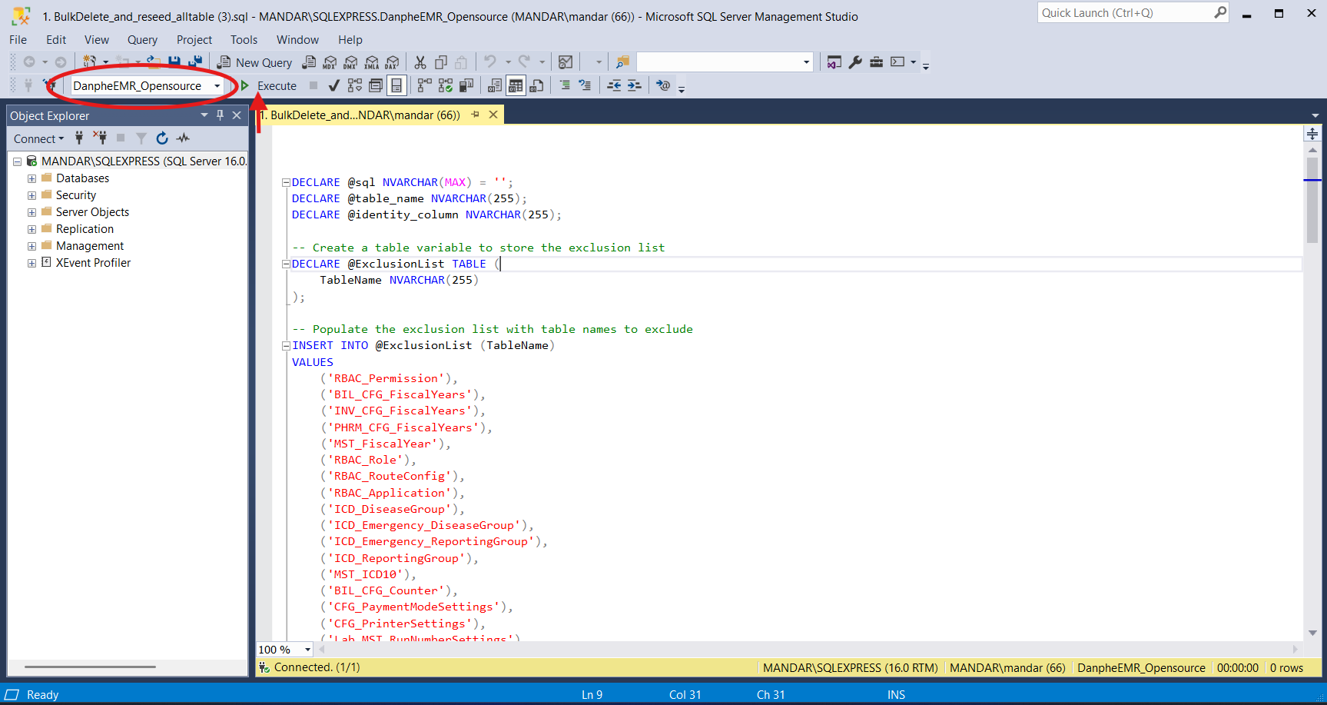

1. **Insert master data & apply constraints** Execute 2. Insert_master_data_and_Check_constraint_V1.1.sql on the **DanpheEMR_Opensource** database.

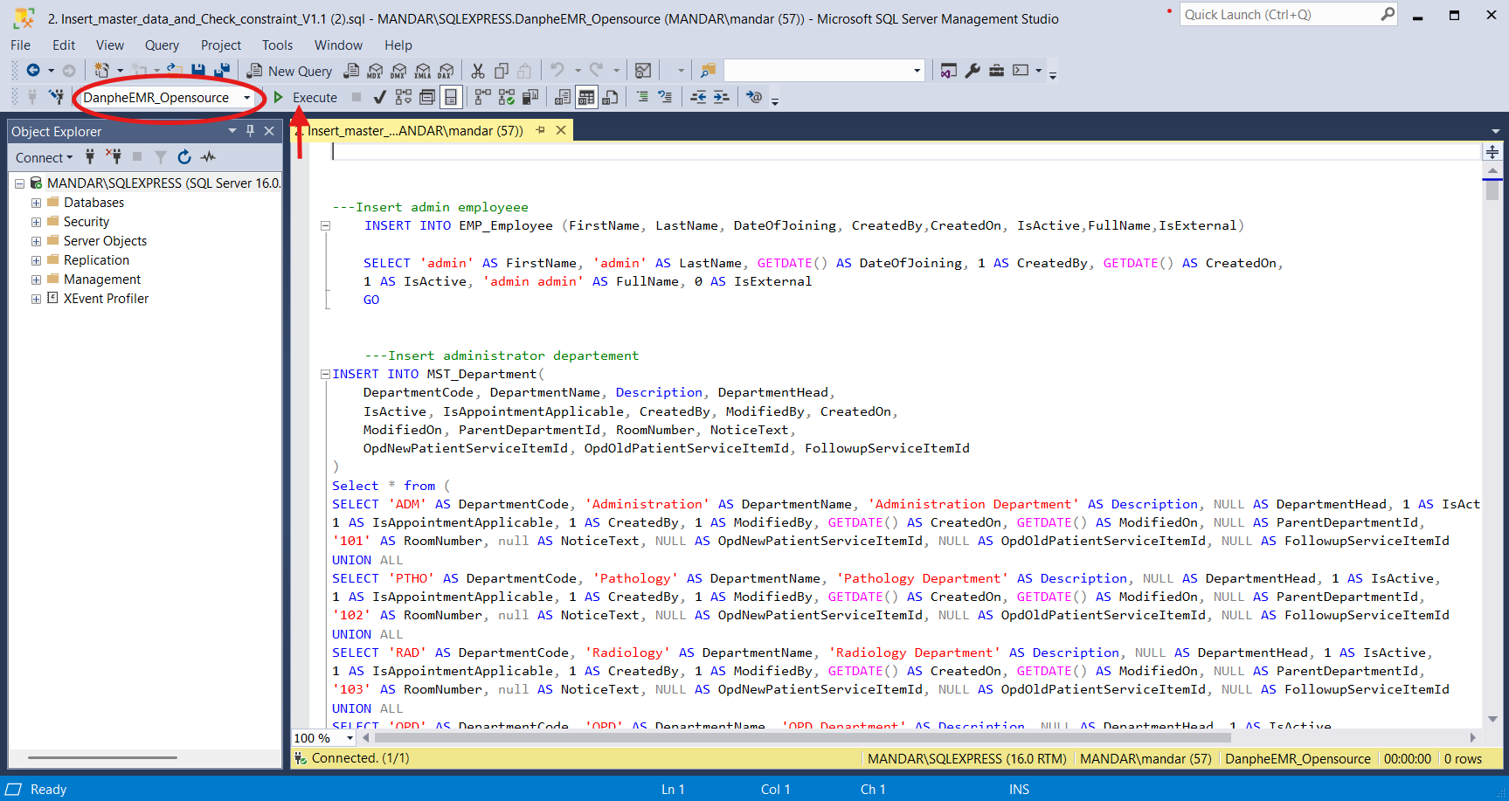

## **2. Master Setup**

### **A. Create Service Departments and Items**

1. Go to:  
    **Settings > Billing > Service Departments** Click **+Add Service Department**, fill in the details, and save.

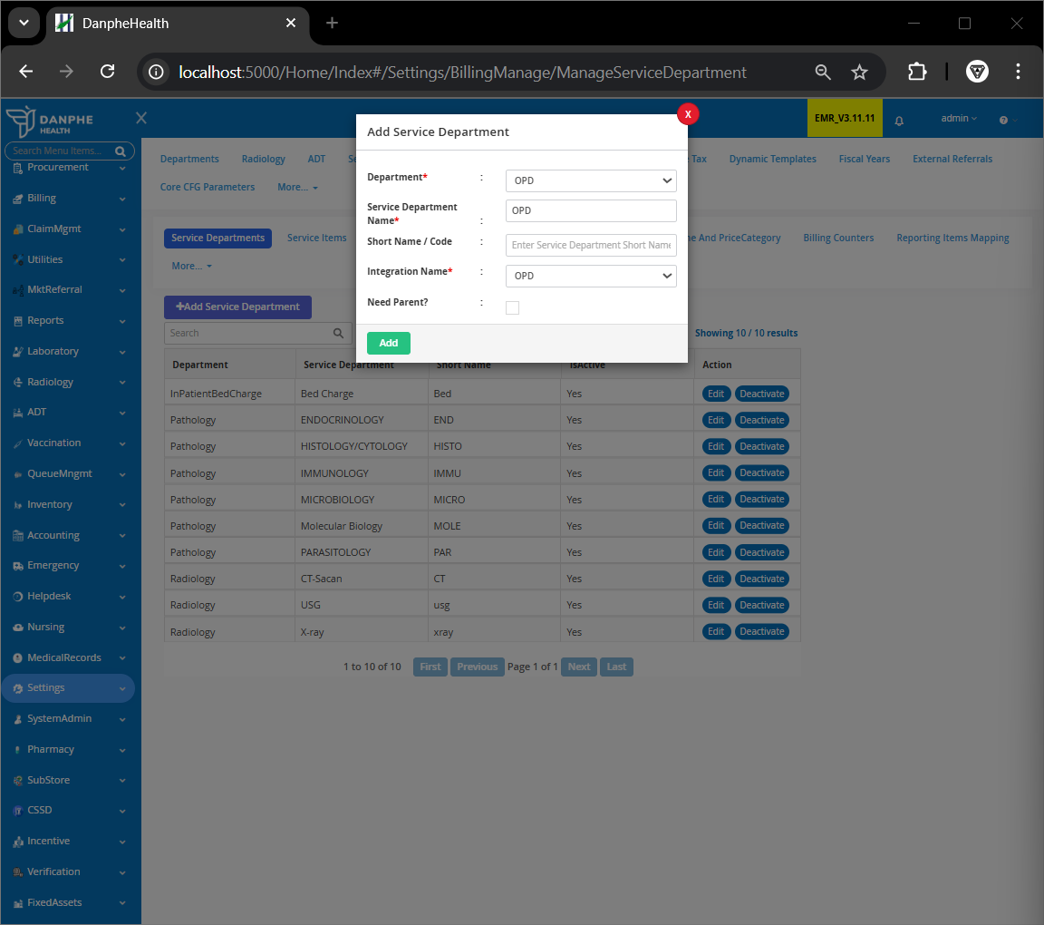

1. Then go to:  
    **Settings > Billing > Service Items** Click **+New Service Item**, fill in the details, and select the service department created earlier.  
     
     
    ⚠️ Items must be added manually the first time. Item codes can be auto-generated afterwards.

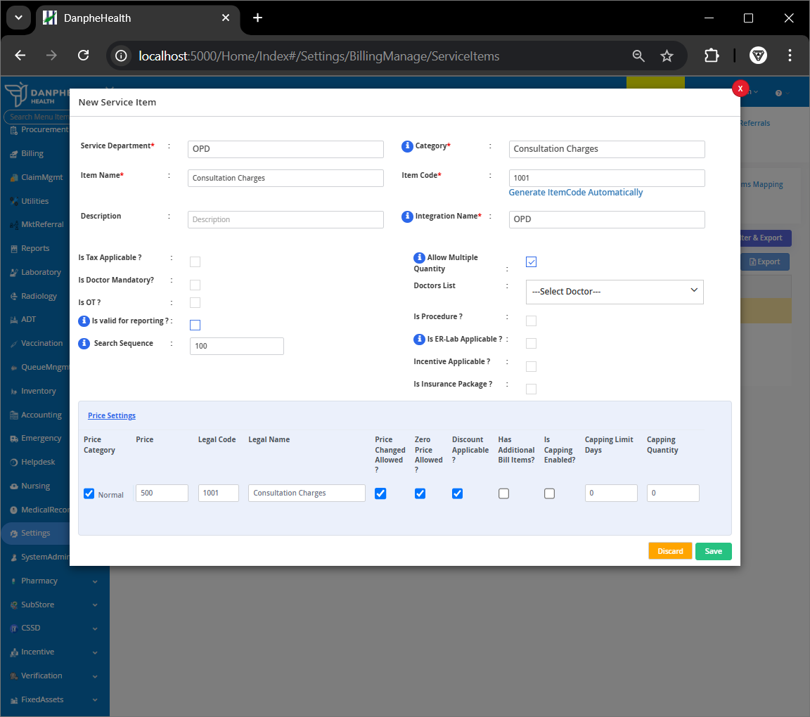

1. Go to:  
    **Settings > Departments > Manage Departments** Find the **parent department** (e.g., OPD), click **Edit**.

1. Under **OPD (New Patient)** tab, select the created service item and click **Update**.

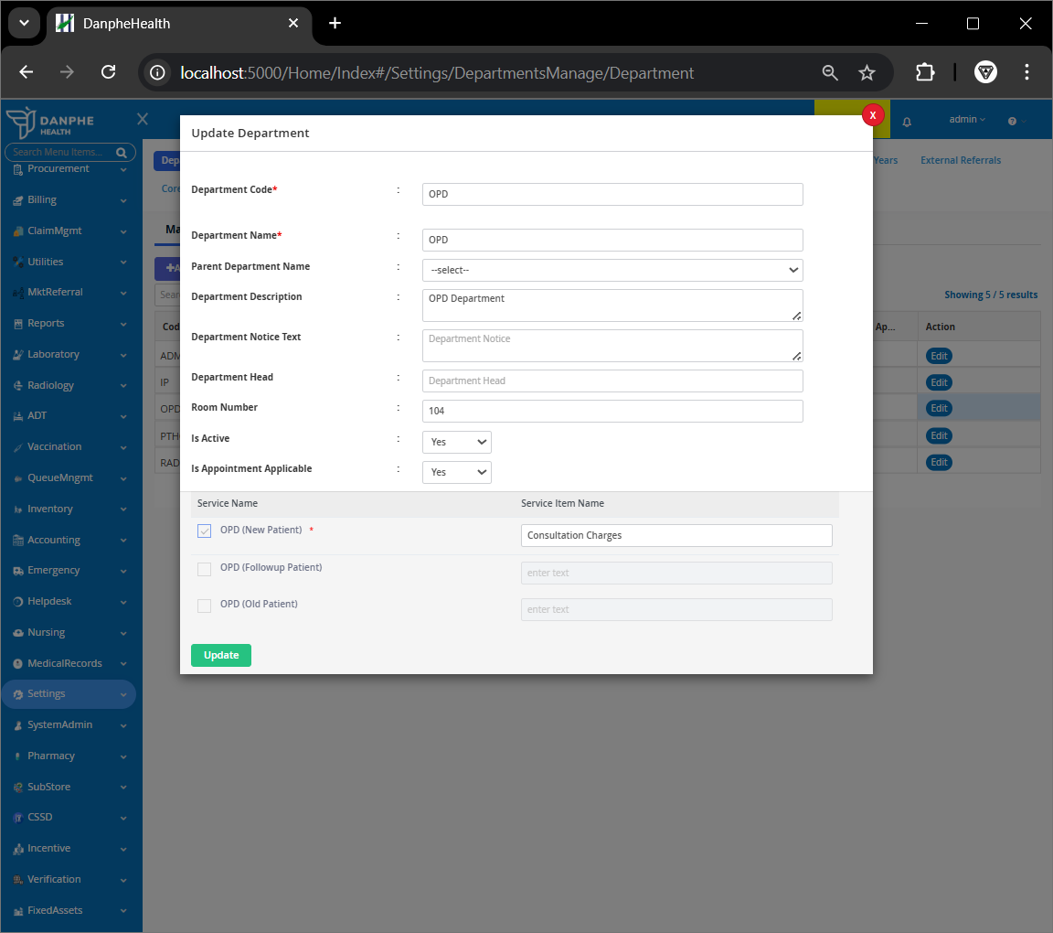

### **B. Add Employees**

1. (Optional) Add salutation:  
    **Settings > Employee > Manage Salutation** Click **Add** to include titles like Dr., Mr., etc.

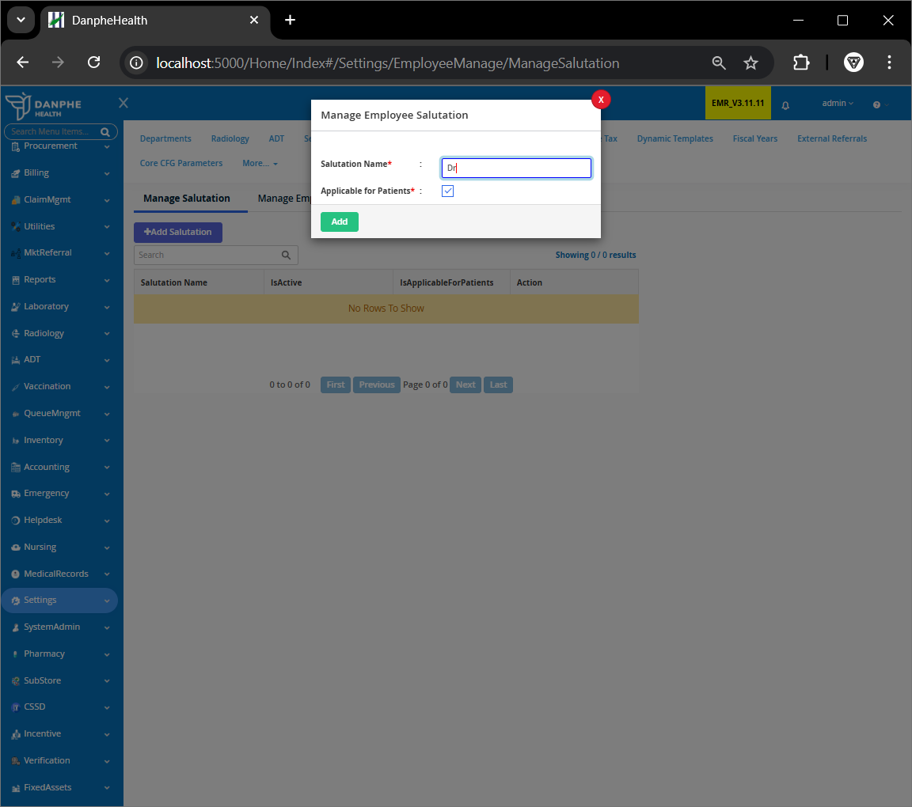

1. Add employee:  
    **Settings > Employee** Click **+Add Employee**, enter the required information, and click **Add**.

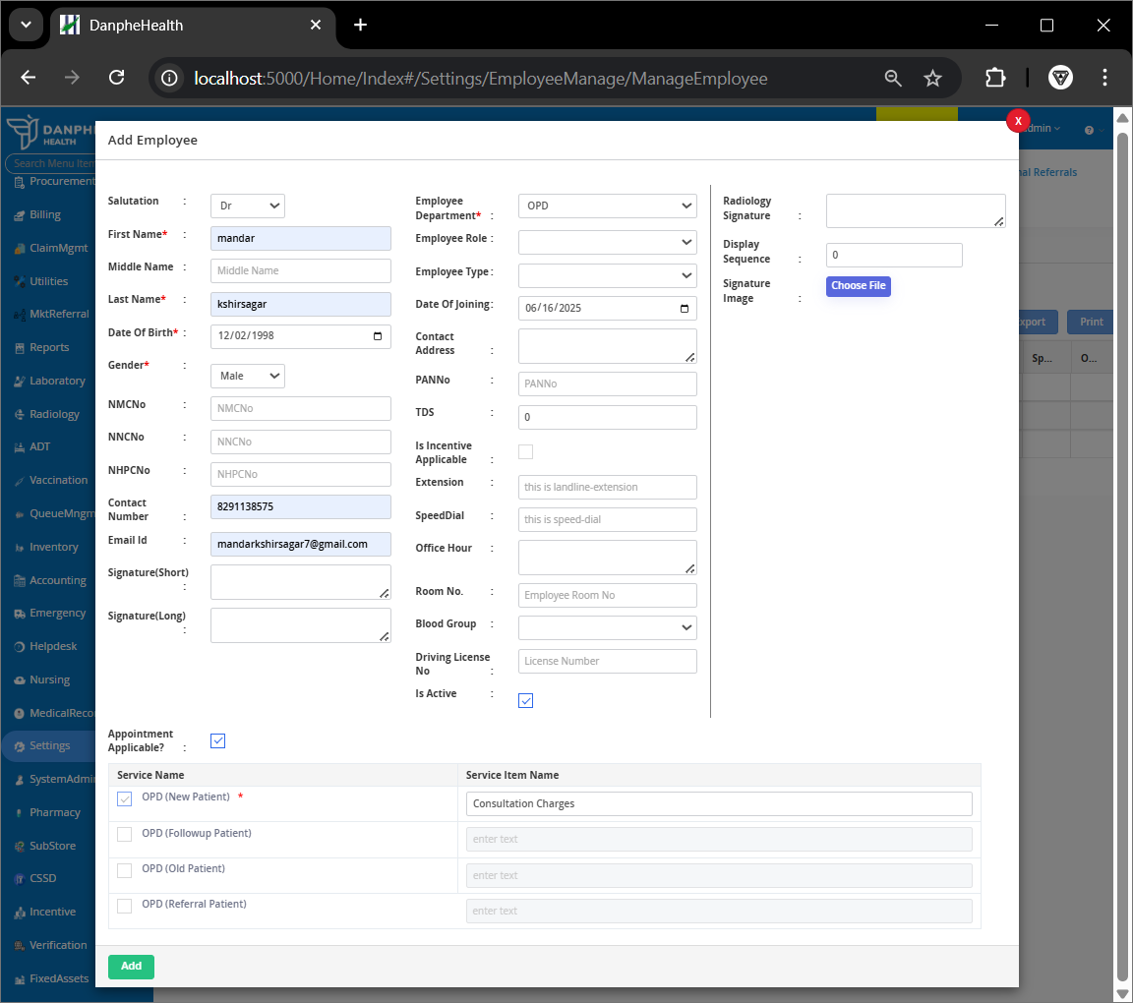

### **C. OPD Consultation Setup**

1. Go to:  
    **Appointment > Select Counter > Manage Visits** Click **+New Patient**, fill in patient details, assign the doctor, and click **Print Invoice** to apply consultation charges.  
   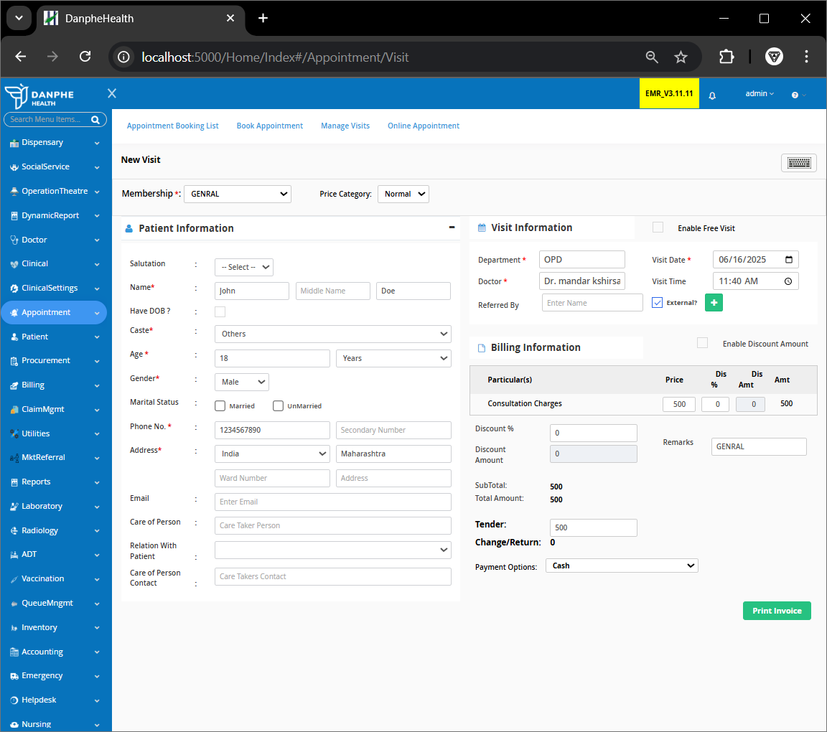
2. 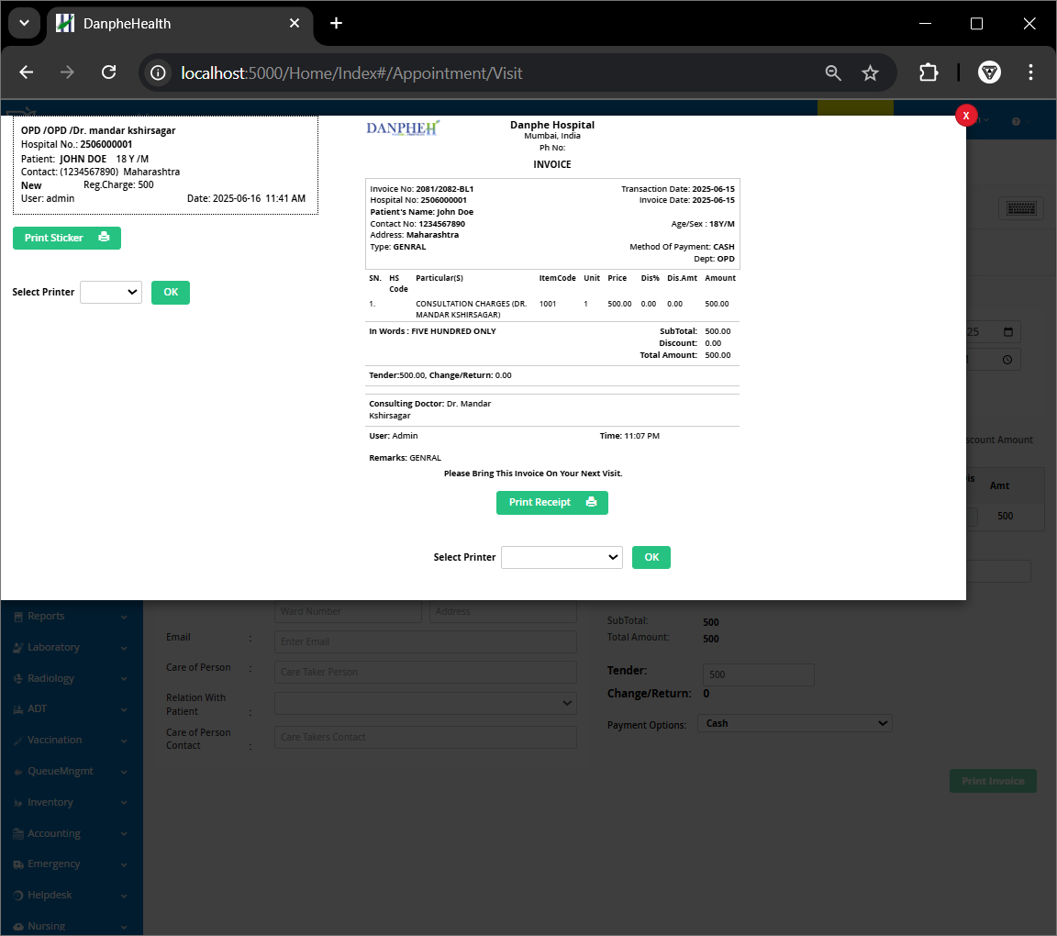

## **3. Clinical (Pharmacy) Setup**

### **A. Configure Medical Sections**

1. Go to:  
    **Clinical Settings > Manage Document/Section > Document/Section List** Click **Manage Section & Mapping** next to **Clinical** tab.

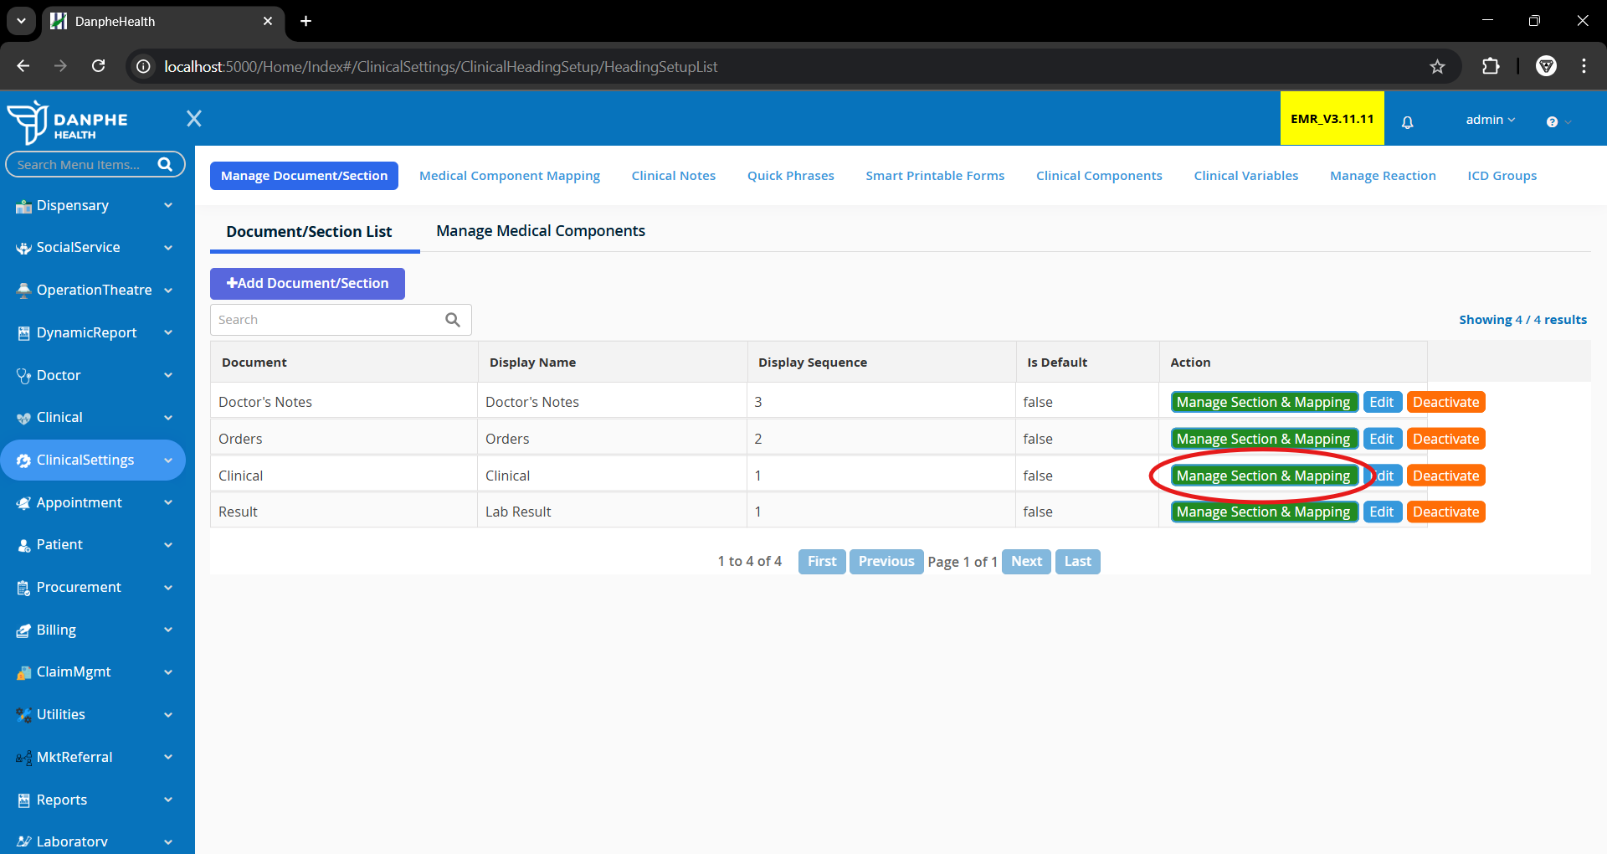

1. For each section:



* + **Vitals:** Tick and save.

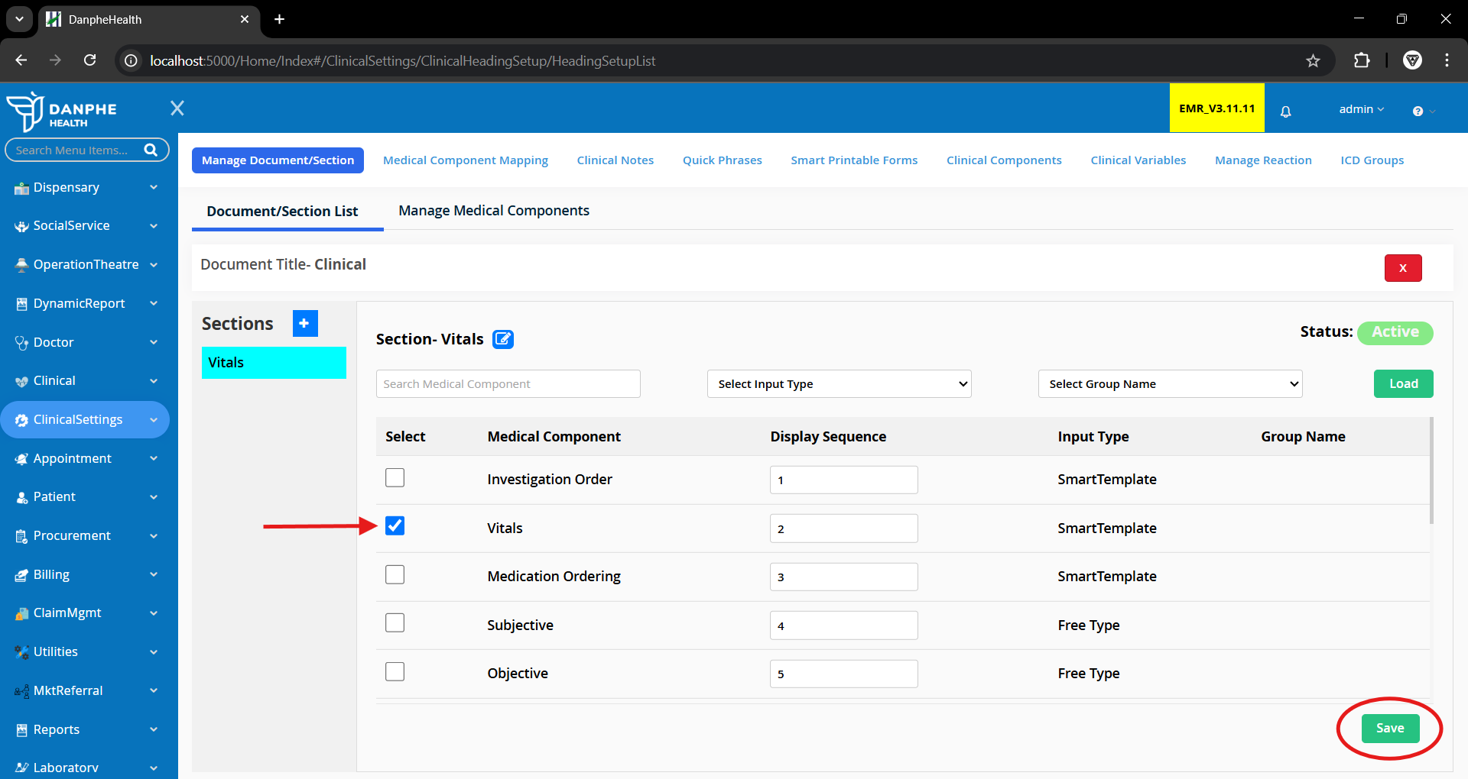

* + **Investigation Orders:** Tick **Investigation Order**, then save.
  + **Medication Order:** Tick **Medication Ordering**, then save.
  + **Doctor’s Note:** Tick **Subjective**, **Objective**, and **Assessment**, then save.
  + **History & Physical:** Tick **Chief Complaint**, **History**, **Physical Note**, then save.
  + **Consult Note:** Tick **Consultation Requests**, then save.
  + **Procedure Note:** Tick **Procedure Plan**, **Comment**, and **Outcome**, then save.
  + **Nursing Note:** Tick **Nurse Note**, then save.

1. Go to:  
    **Clinical Settings > Medical Component Mapping**
   * Click **+Add Medical Component Mapping**
   * Document: **Clinical**, Section: **Vitals**, Department: **OPD**, Employee: **admin**
   * Proceed, tick the box, and save.

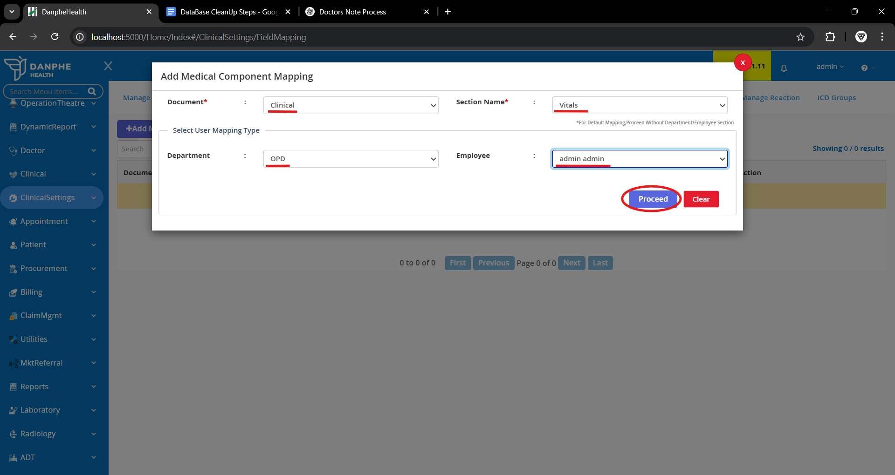

1. Repeat Step 4 for all other components listed above.
2. To activate modules for a new employee, repeat Step 4 using their name.

## **4. Pharmacy Setup**

### **A. Basic Setup**

1. **Add Supplier:** Go to **Pharmacy > Settings > Supplier**, click **Add Supplier**, fill details, and save.

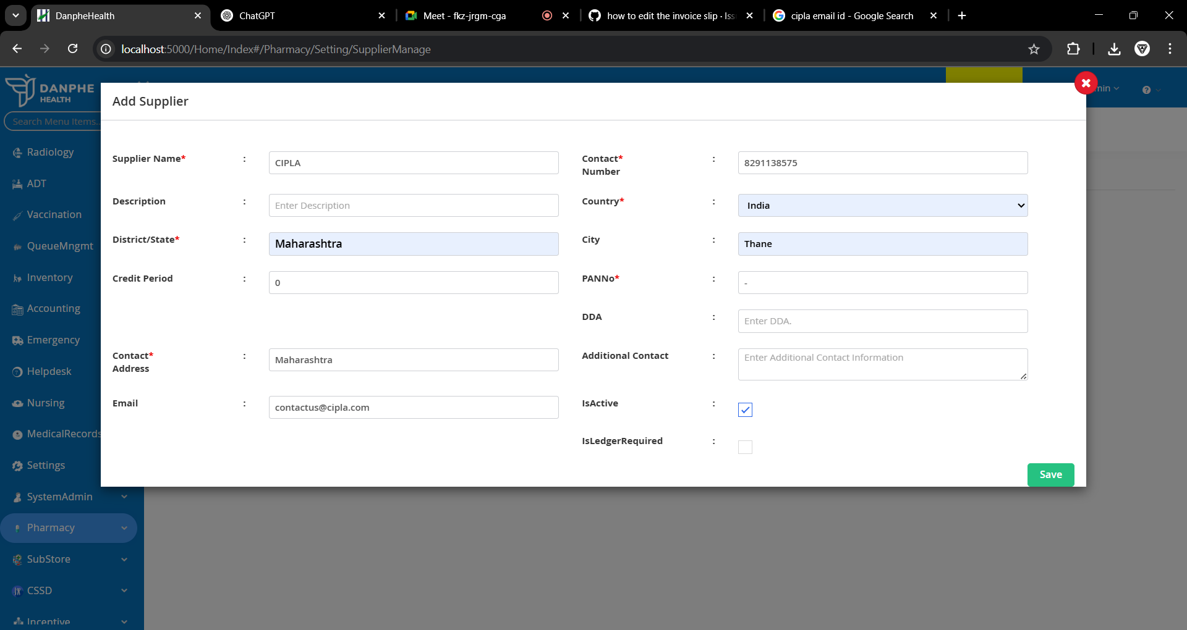

1. **Add Company:** Go to **Settings > Company**, click **Add Company**, fill details, and save.

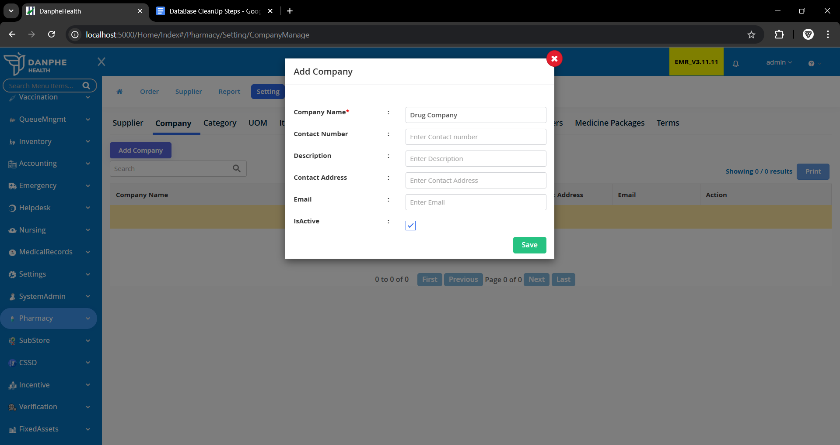

1. **Add Category:** Go to **Settings > Category**, click **Add Category**, fill details, and save.

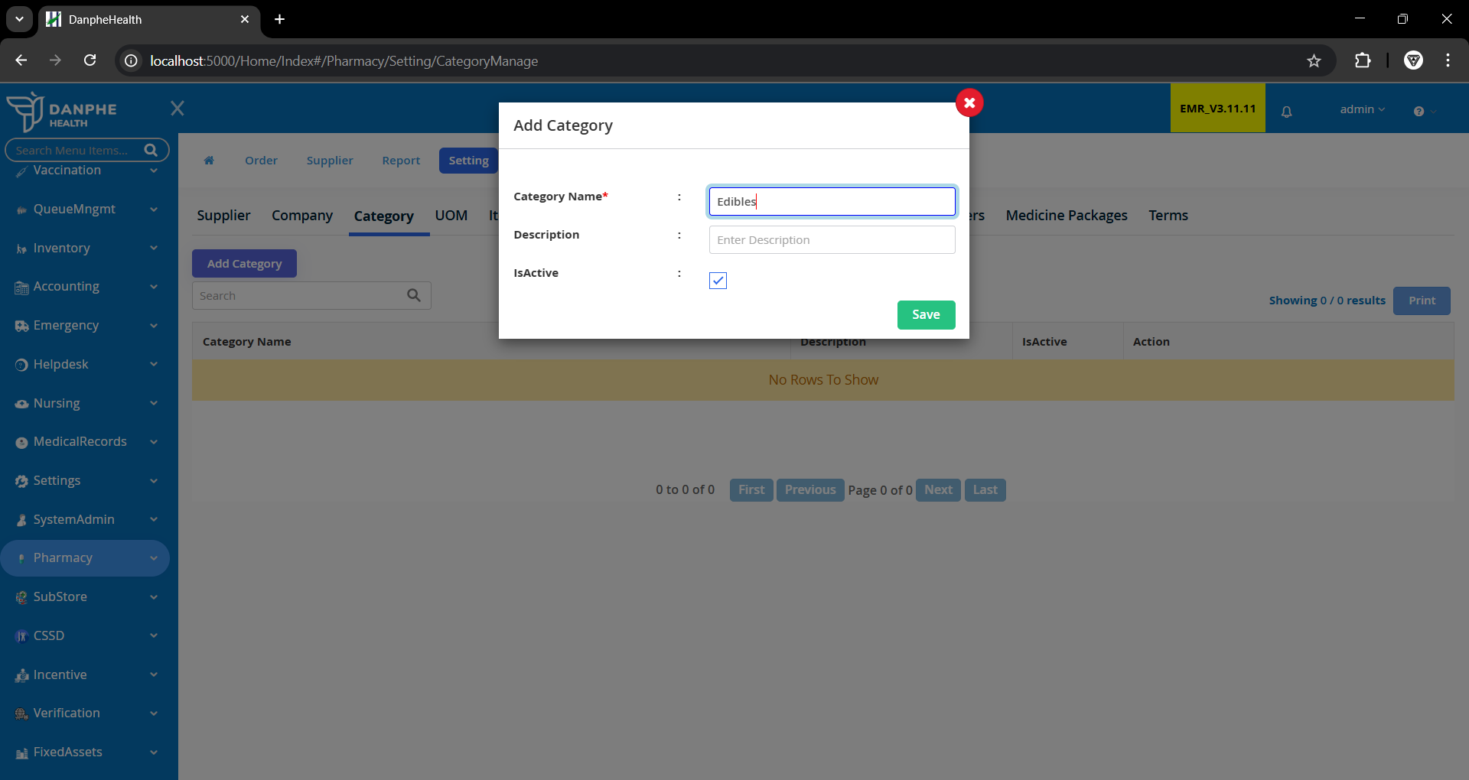

1. **Add Unit of Measurement (UOM):** Go to **Settings > UOM**, click **Add Unit of Measurement**, enter unit, and save.

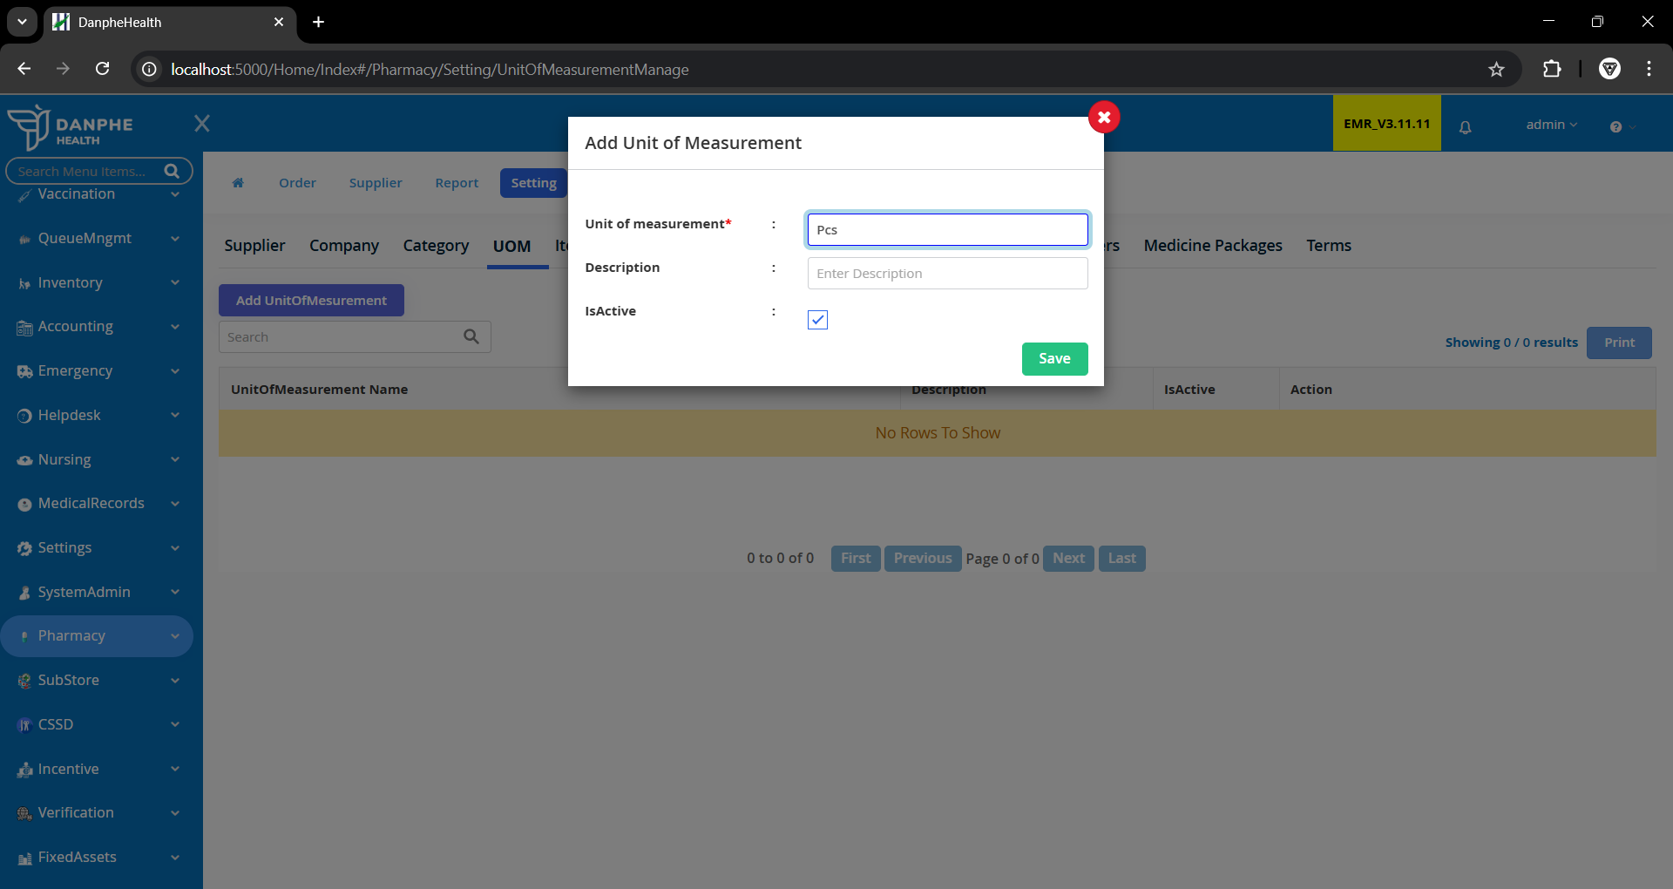

1. **Add Item Type:** Go to **Settings > ItemType**, click **Add ItemType**, select category, and save.

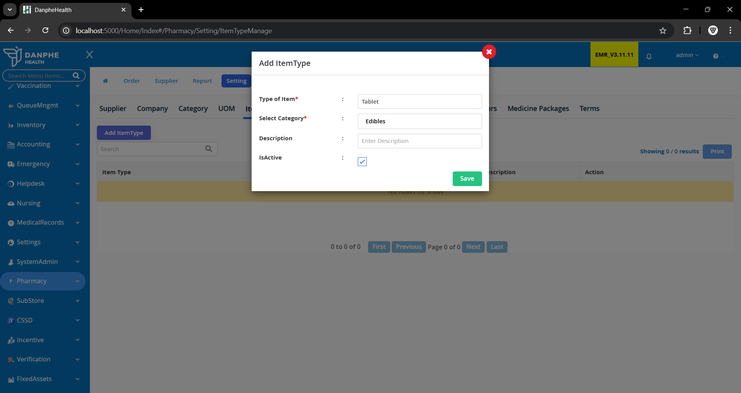

1. **Add Generic Name:** Go to **Settings > Generic**, click **Add New Generic Name**, select category, and save.

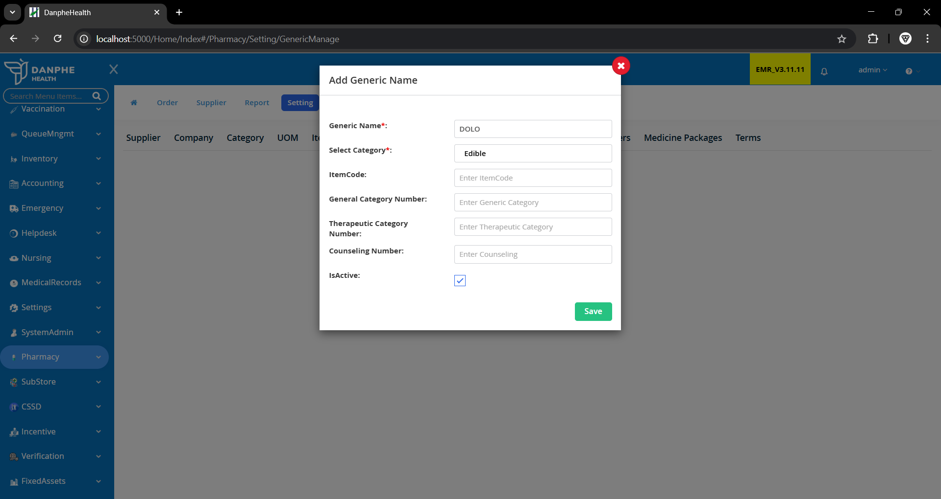

1. **Add Medicines:**
   * Hard refresh dashboard (**Ctrl + Shift + R**)
   * Go to **Pharmacy > Settings > Items**, click **Add Items**, fill details, and save.

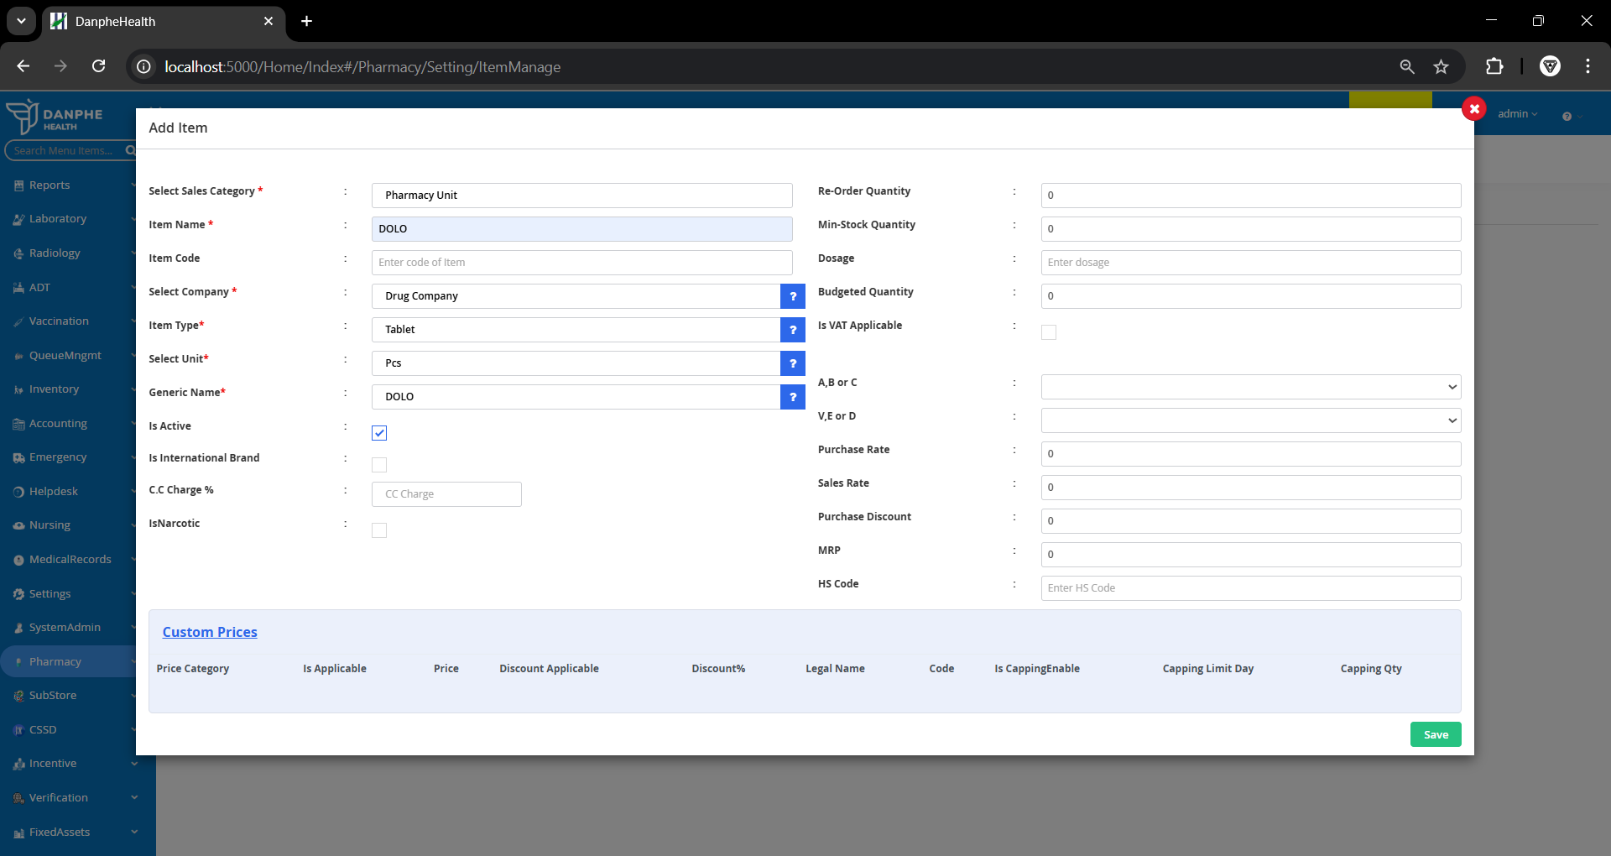

### **B. Stock Medicines in Dispensary**

1. **Create Purchase Order:** Go to **Pharmacy > Order > Purchase Order**, click **Add**, add supplier, items, quantity, then click **Print Order**.  
   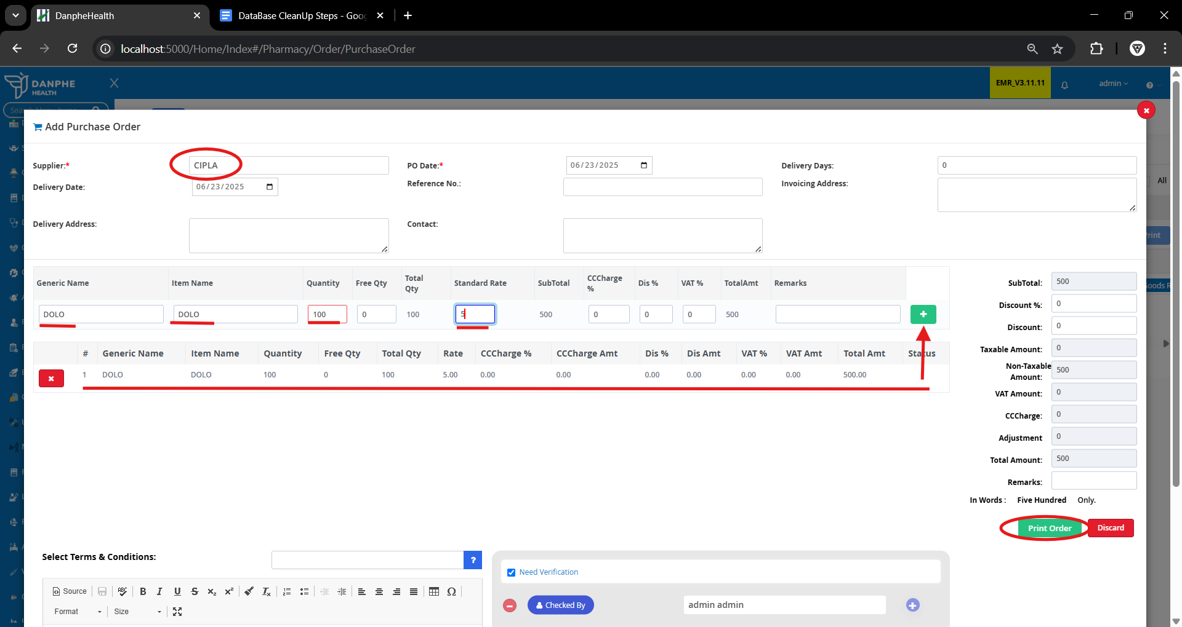
2. **Verify Purchase Order:** Go to **Verification > Pharmacy > Purchase Order**, click **Verify**, add remarks, and **Approve**.  
   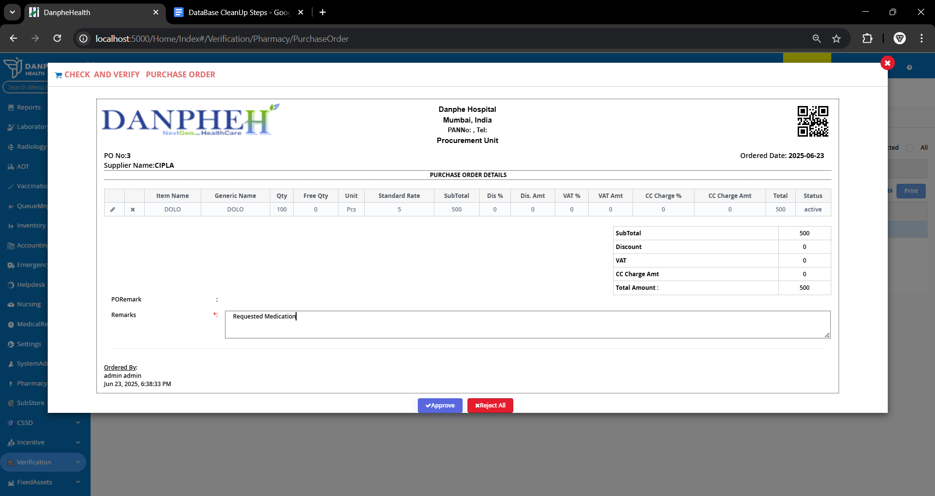
3. **Goods Receipt:** Go to **Pharmacy > Order > Purchase Order**, click **Add Goods Receipt**, add invoice number, batch number, and **Print Receipt**.  
   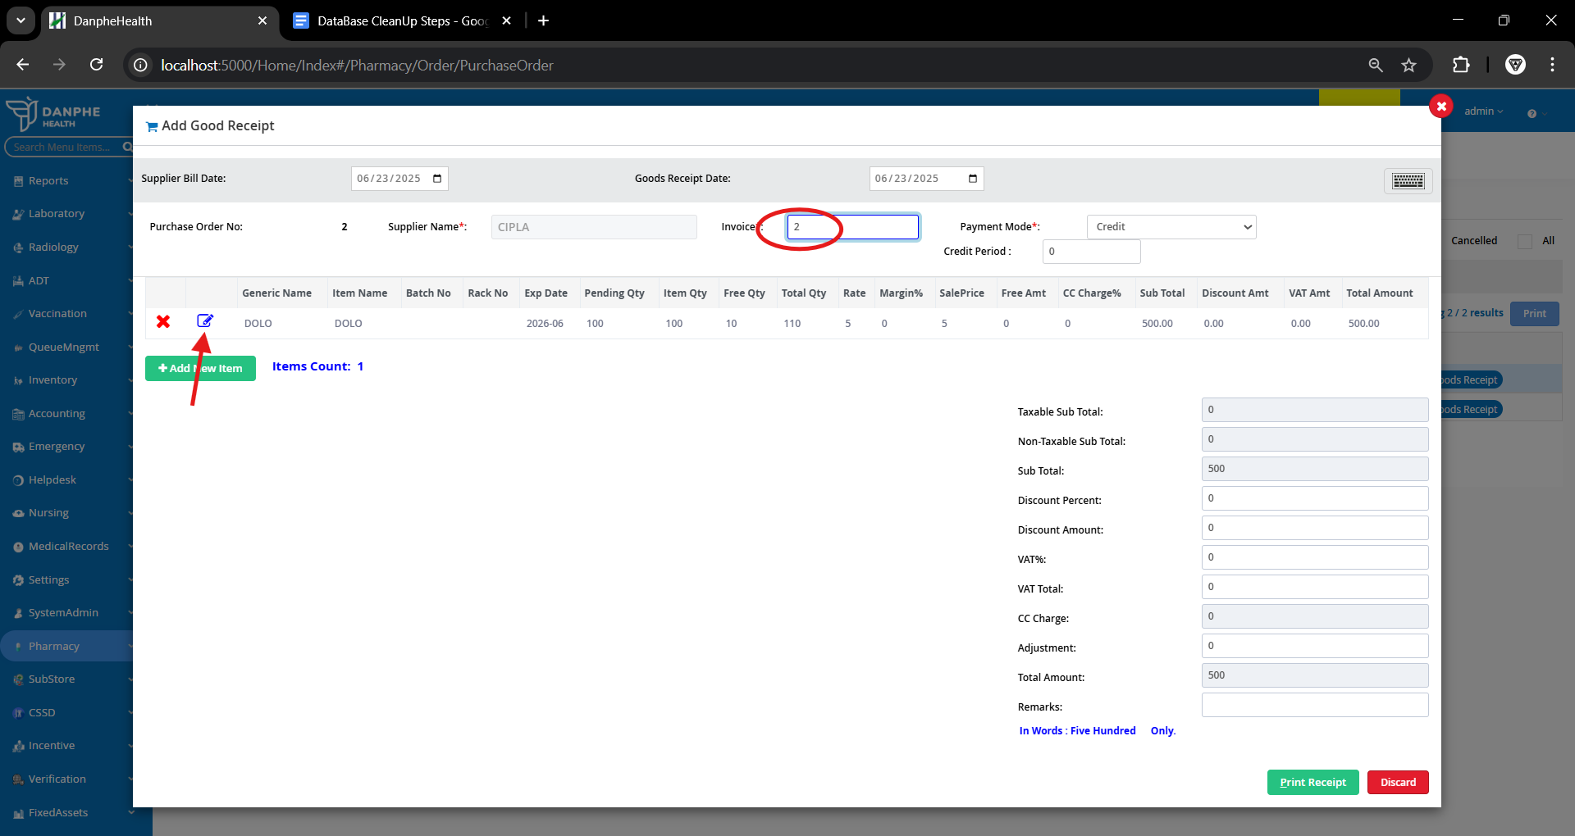
4. **Direct Dispatch:** Go to **Pharmacy > Substore request/Dispatch**, select **Main Dispensary**, add item, quantity, remarks, and click **Direct Dispatch**.  
   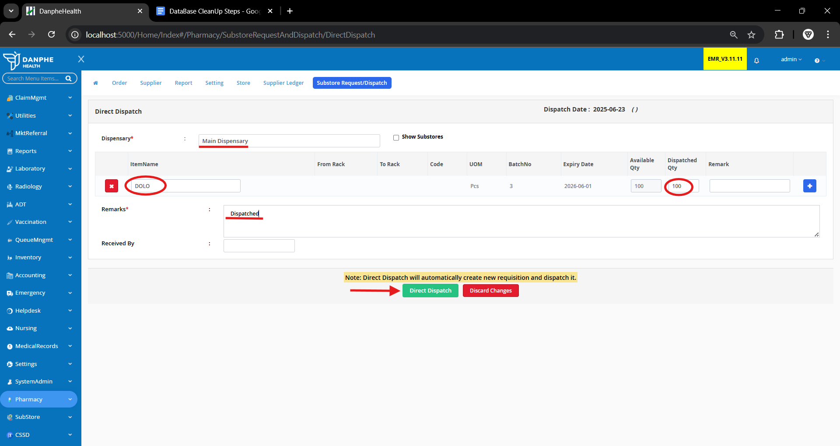
5. **Receive Items:** Go to **Dispensary > Stock > Requisition**, click **Receive Items**.  
   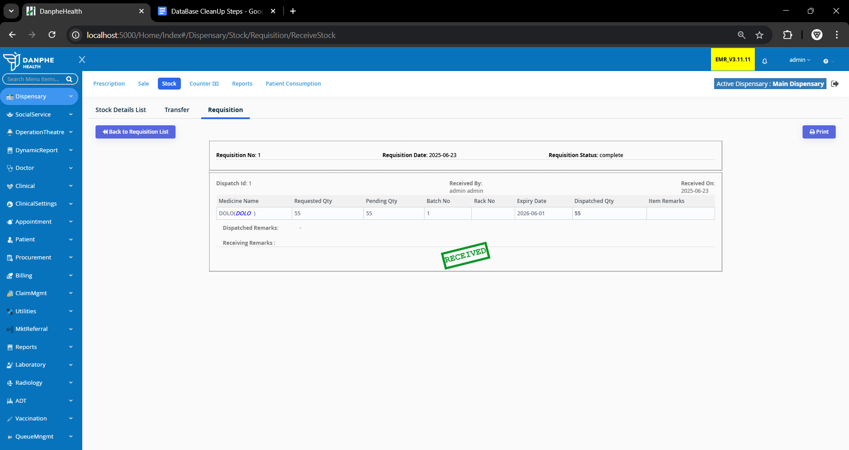

### **C. Order Medication for Patient**

1. **Add Patient:** **Appointment > Select Counter > Manage Visit** Click **+New Patient**, add details, assign doctor, and print invoice.

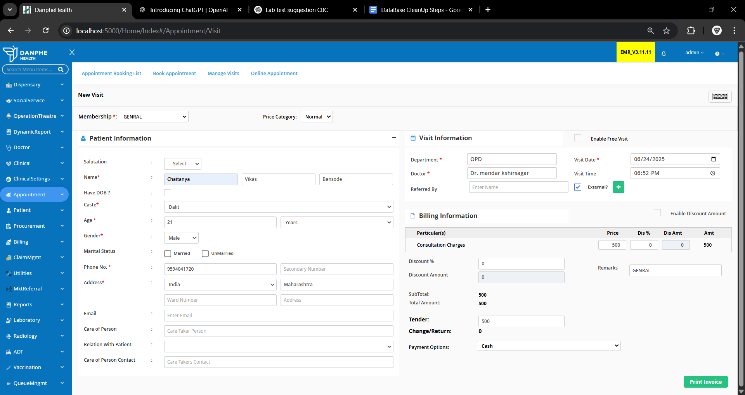

1. **Patient Visit:** **Clinical > Out Patient > Patient Visit** Click **Action** next to patient.  
   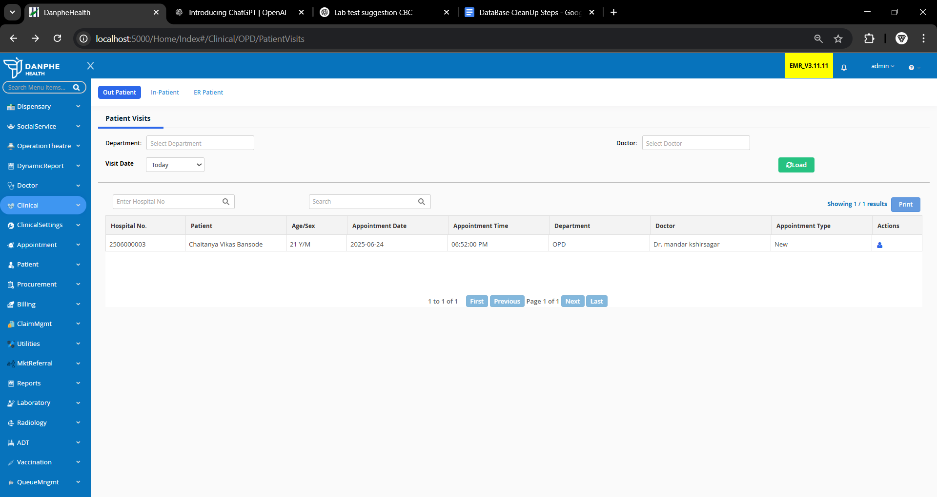
2. **Request Medication:** In the **Orders** section, click **Request Medication**, fill details, click **+** icon, then **Add**.  
   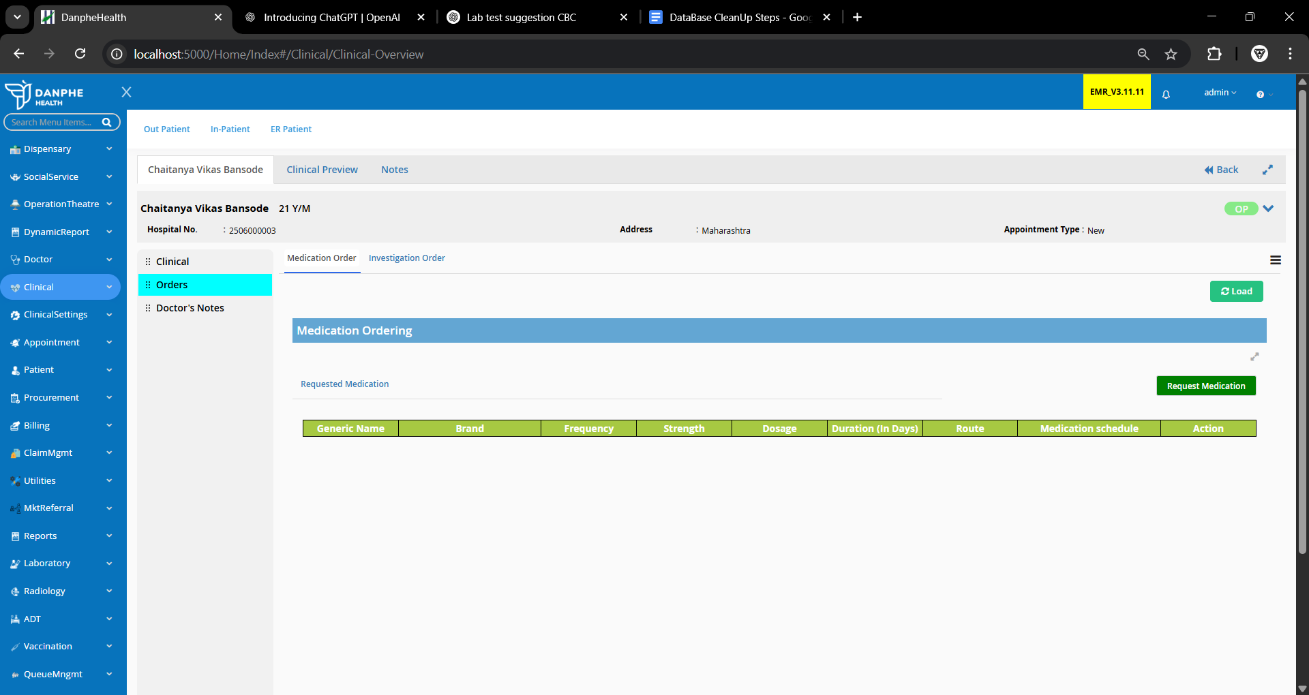
3. 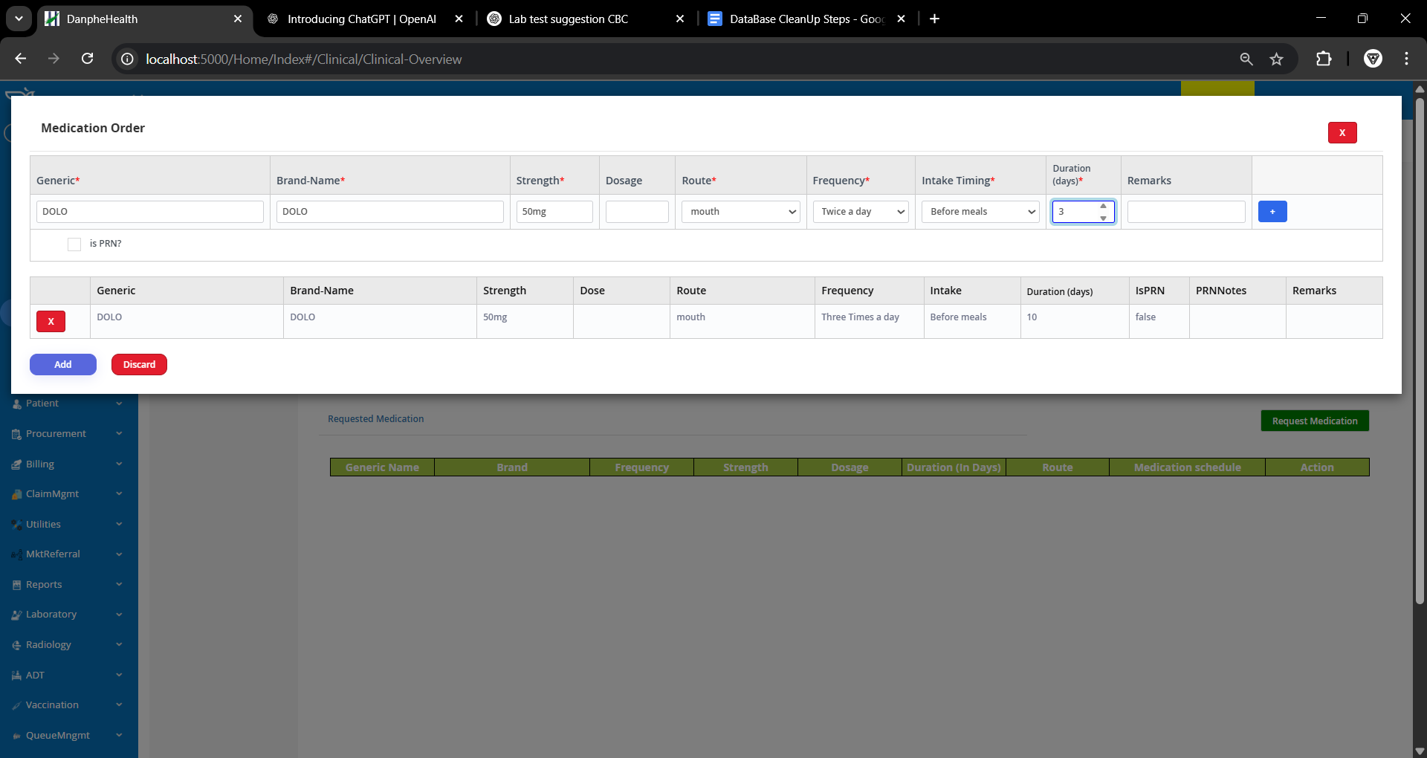
4. **Dispense Medicine:** Go to **Dispensary > Select Counter > Sale**, search patient, fill quantity, click **Update Prescribed Quantity**, then **Proceed to Sale**.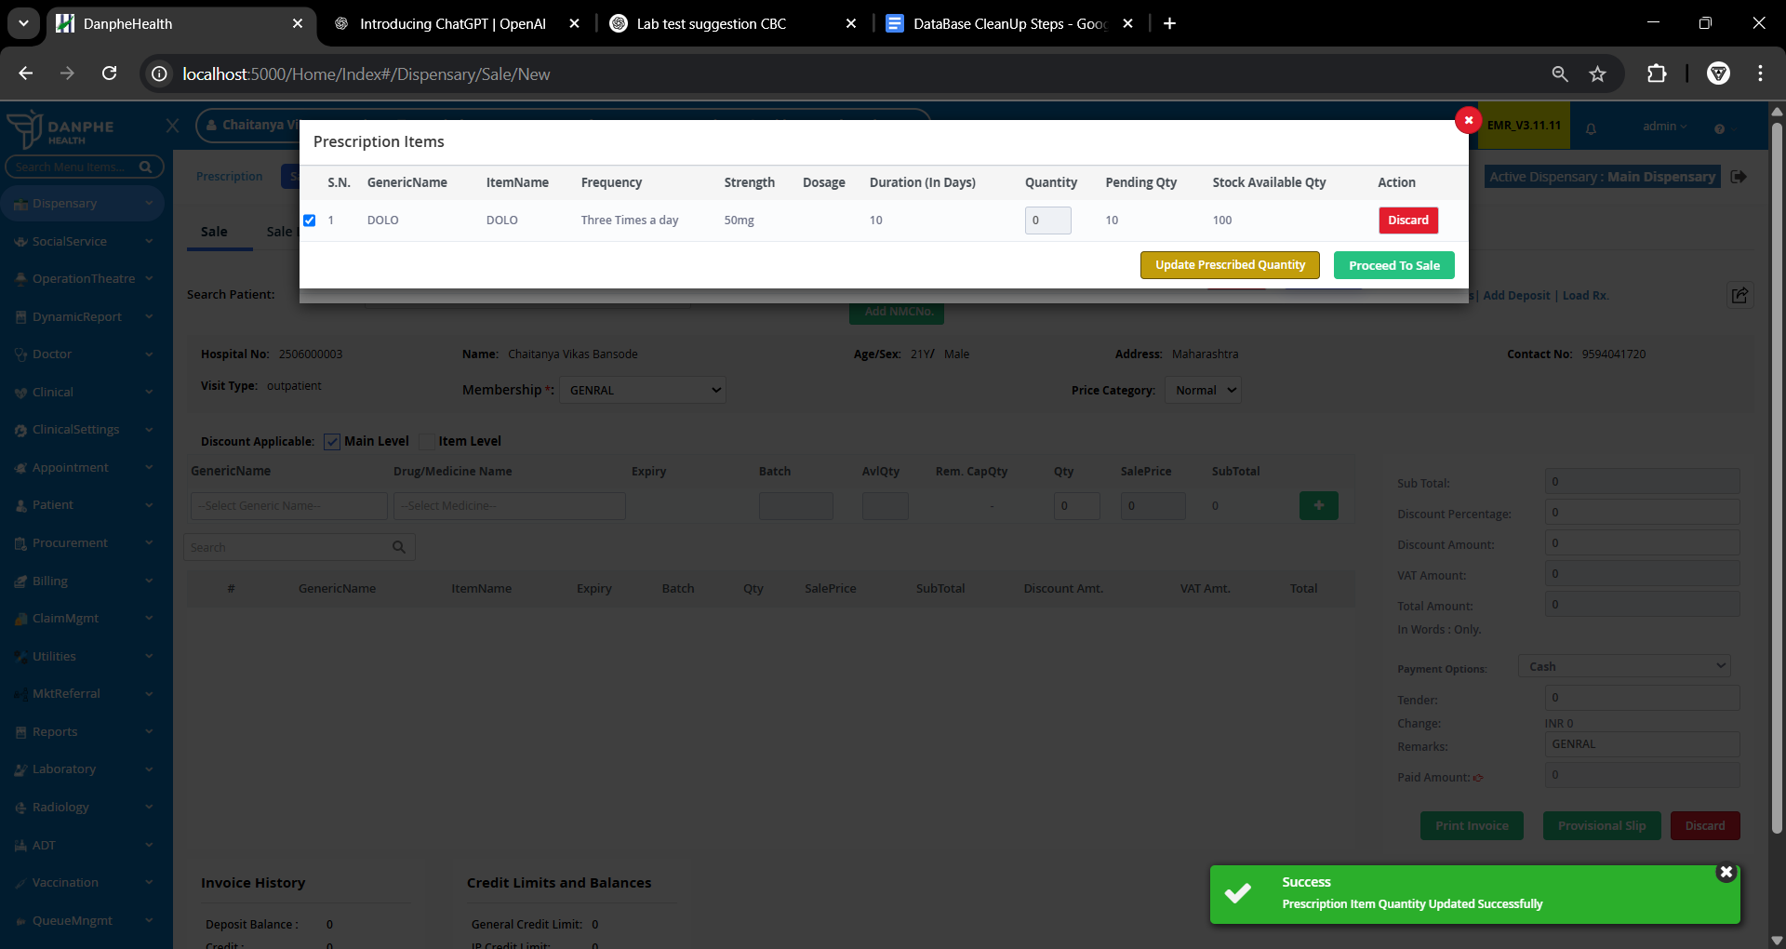
5. **Print Invoice:** Click **Print Invoice** to complete the order.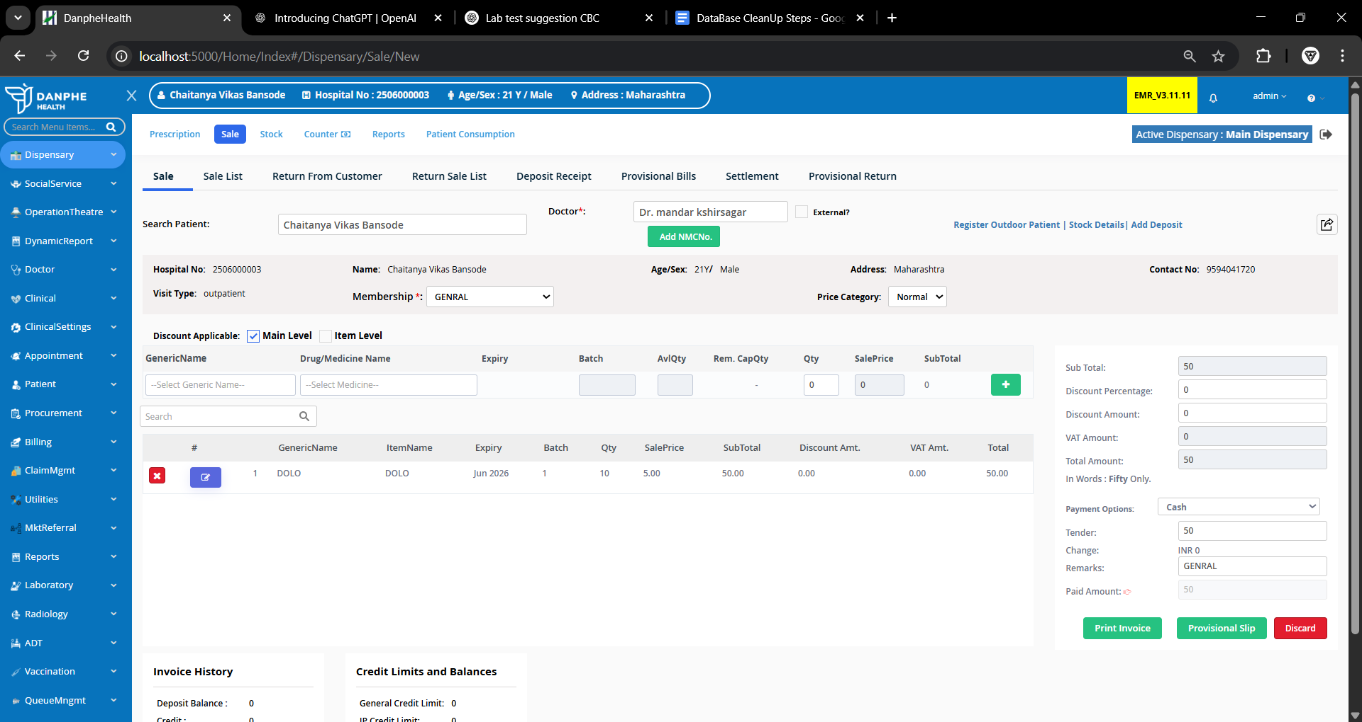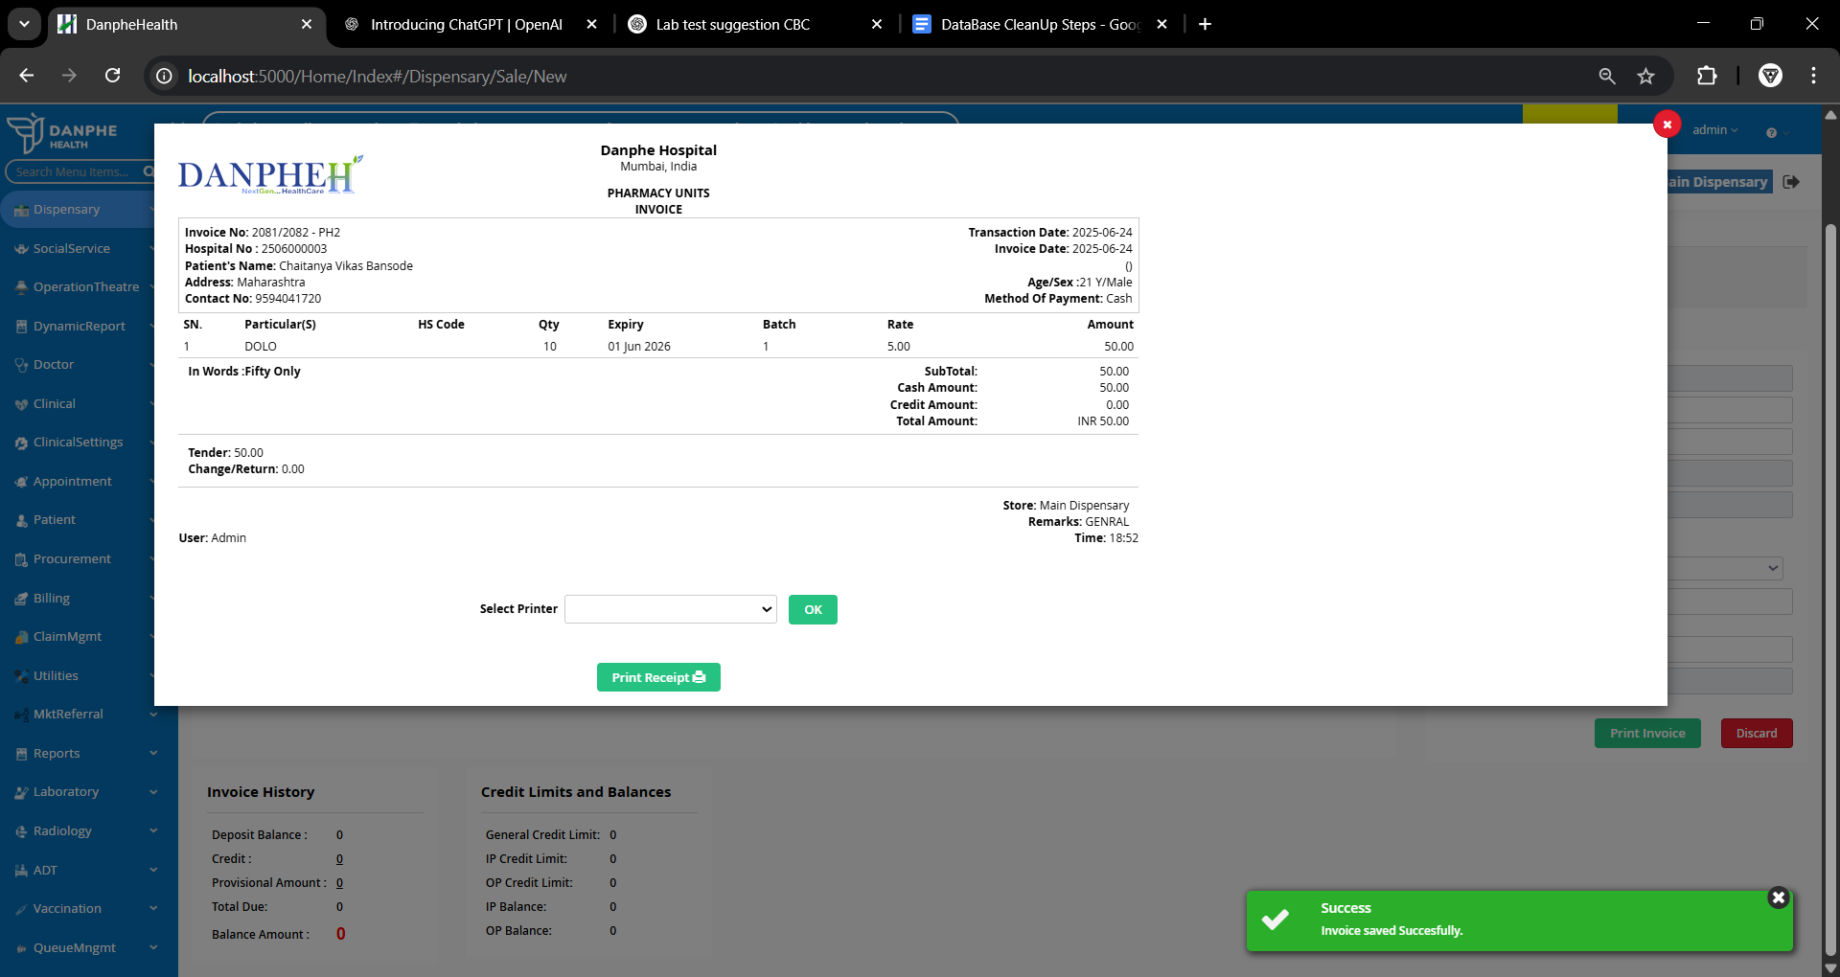

## **5. Laboratory Setup**

**A.Setting up Lab test**

1. **Add Lab Category:** Go to **Laboratory > Settings > Lab Categories**, click **+Add New Lab Category**, name it, and save.  
   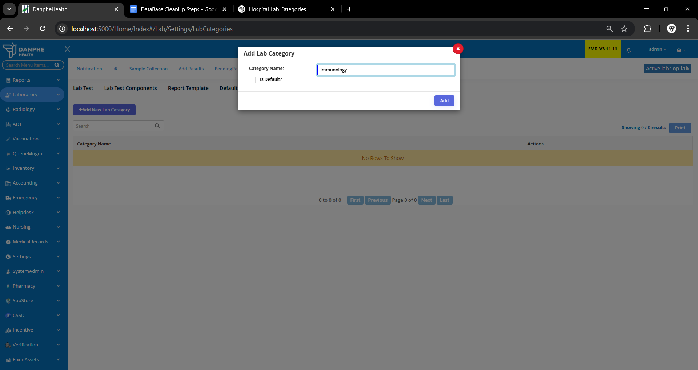
2. **Add Lab Components:** Go to **Lab Test Components**, click **+Add New Lab Test Component**, enter name, and save.  
   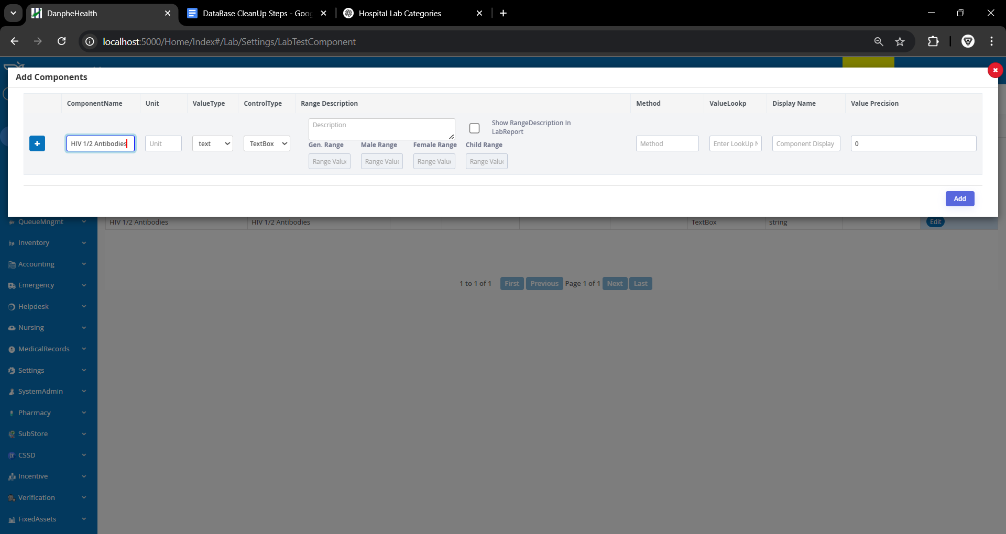
3. **Create Lab Report Template:** Go to **Report Template**, click **+Add New Lab Template**, add name/type, and save.  
   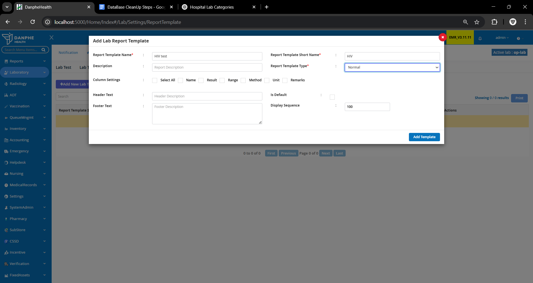
4. **Add Lab Test:** Go to **Lab Test**, click **+Add New Lab Test**, fill name, specimen, code, report template, service department, and select the added component. Then click **Add**.  
   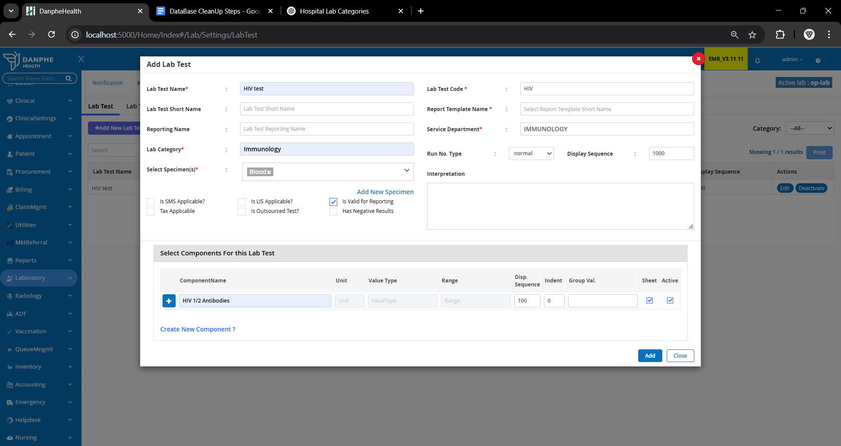
5. **Add Lab Employee:**

Go to Settings > Employee > Manage Employee, Click **+Add Employee,** Add a Employee in pathology department and make sure that Appointment applicable column is unticked and add lab signature.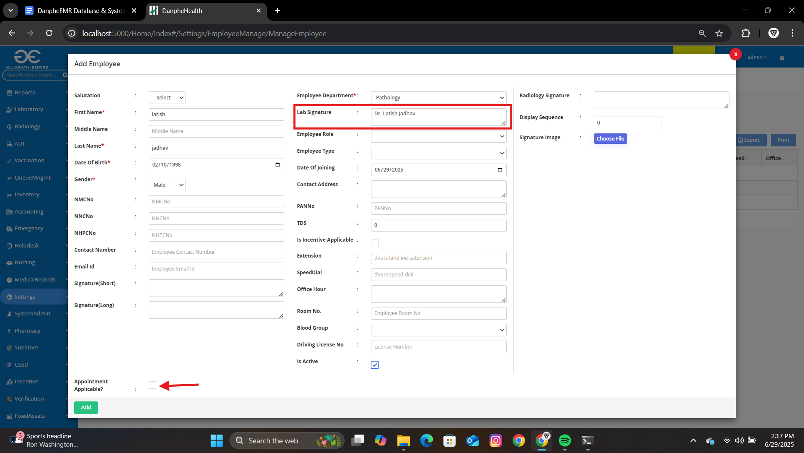

**6.Add Prices to the lab test**

Go to Settings > Billing > Service Item And Search for added lab test,Add category as service charge In price setting add the cost and click on save and update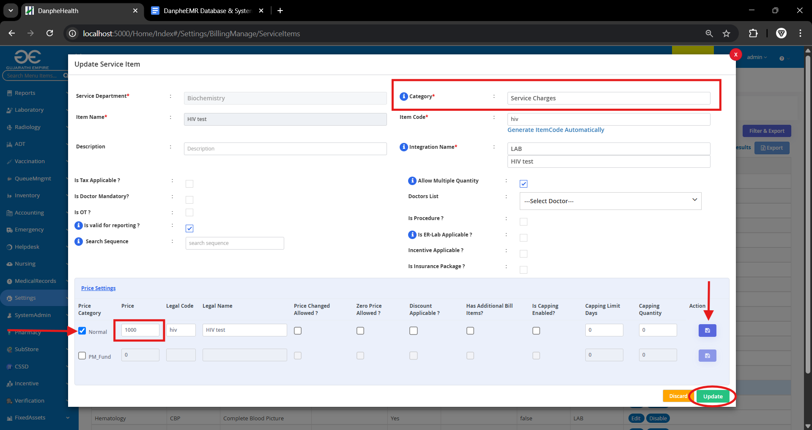

**B.Ordering Lab Test for the Patient**

1. **Requesting lab test**

Go to Clinical > Order Section > Investigation Order and click click on **+Request**  button and add the lab test in item name tab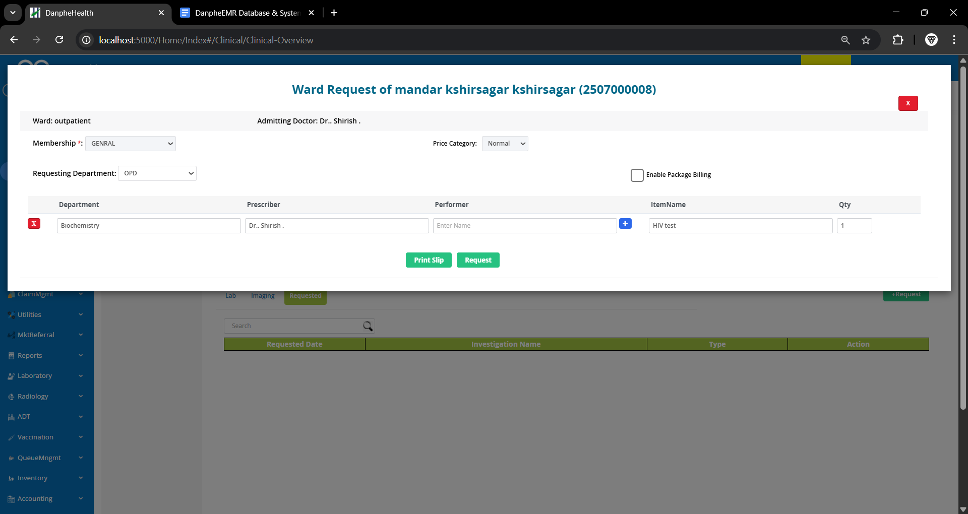

1. **Collecting Samples**

Go to Laboratory > Sample collection, click on view details next to patient and click on collect sample and click close.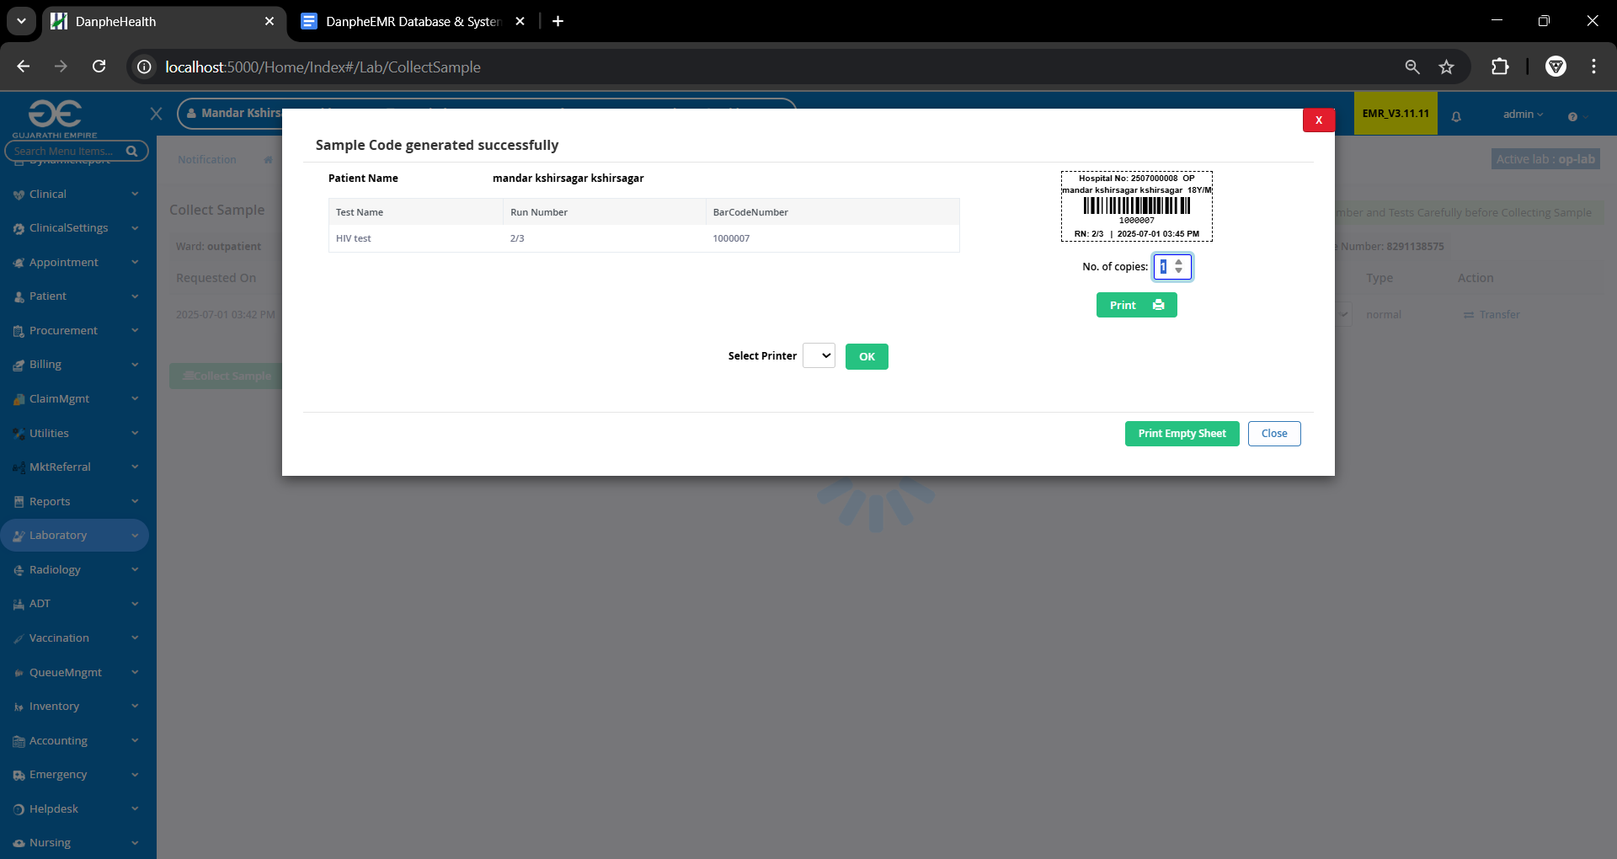

1. **Adding result**

Go to Add Result and Add the value from collected sample and click on save results

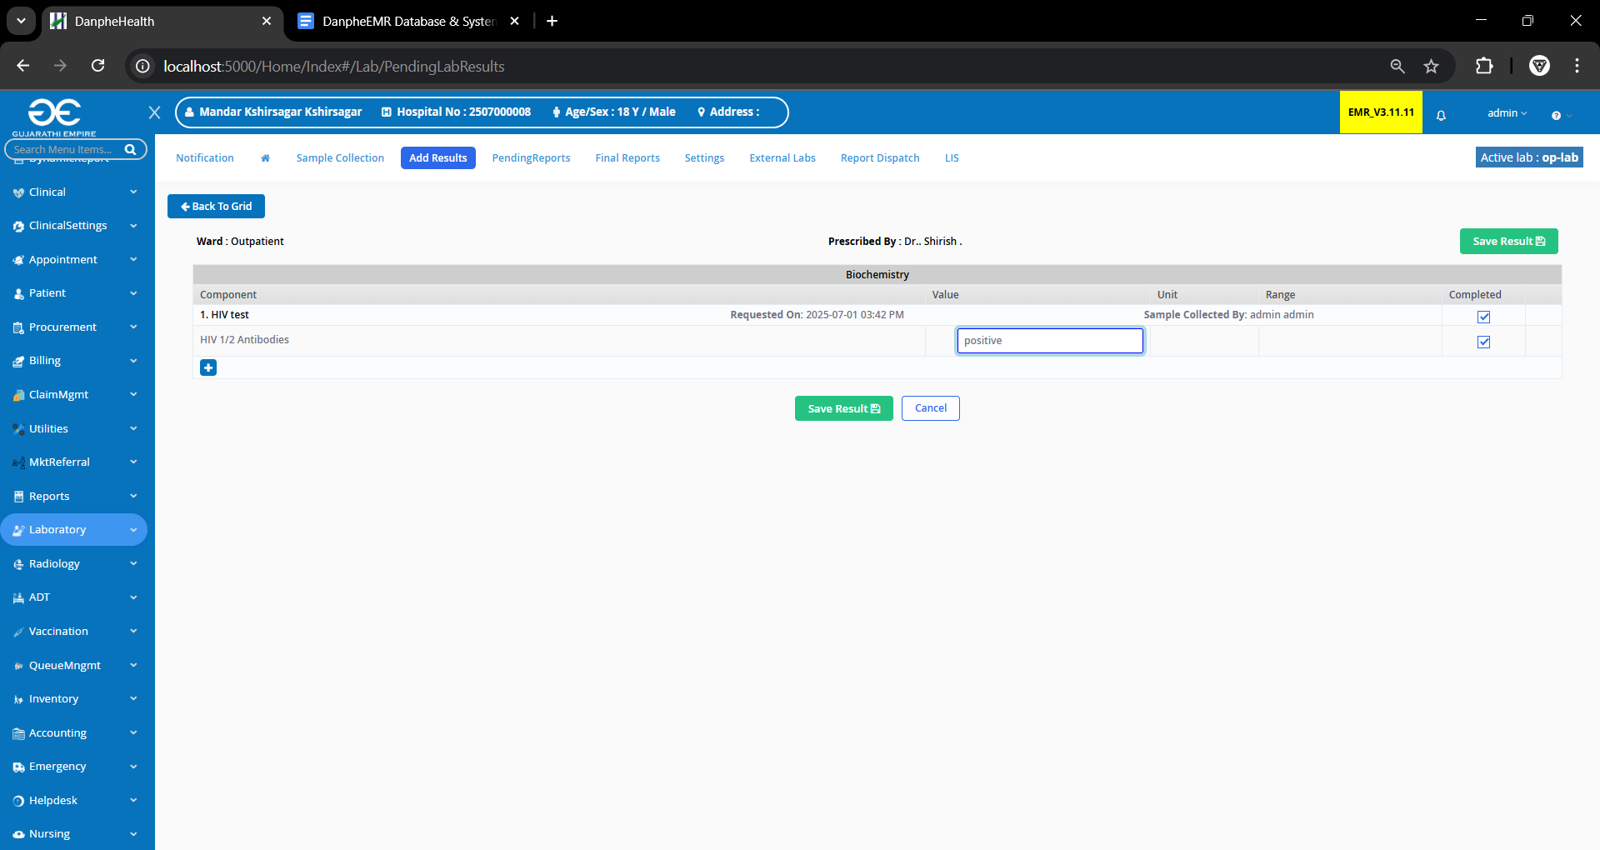click on save signatories and save.

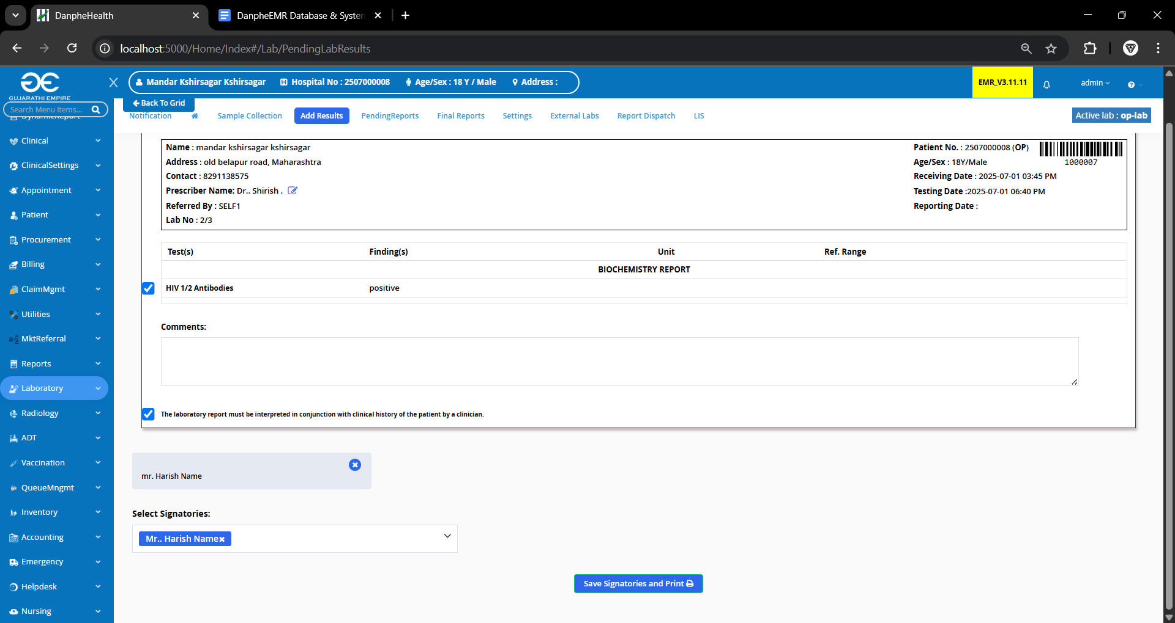

4.**Billing the patient**

Go to Billing> Provision Clearance and select the patient and click on view details, click on pay now and print invoice